Protocol for the Examination of Specimens From Patients With Carcinoma of the Penis

Version: 4.2.0.0
Protocol Posting Date: September 2023
CAP Laboratory Accreditation Program Protocol Required Use Date: June 2024
The changes included in this current protocol version affect accreditation requirements. The new deadline for implementing this protocol version is reflected in the above accreditation date.

For accreditation purposes, this protocol should be used for the following procedures AND tumor types:
Procedure | Description
Penectomy | Includes specimens designated partial penectomy and total penectomy.
Circumcision | Required if margins can be assessed.
Tumor Type | Description
Carcinoma | Includes carcinomas arising from foreskin, glans, or penile shaft.

This protocol is NOT required for accreditation purposes for the following:
Procedure
Biopsy (incisional or excisional)
Primary resection specimen with no residual cancer (e.g., following neoadjuvant therapy)
Cytologic specimens

The following tumor types should NOT be reported using this protocol:
Tumor Type
Urothelial carcinoma (consider Urethra protocol)
Lymphoma (consider the Hodgkin or non-Hodgkin Lymphoma protocols)
Sarcoma (consider the Soft Tissue protocol)

Authors
Lara R. Harik, MD, FCAP*; Antonio L. Cubilla, MD*; Gladell P. Paner, MD, FCAP*; Maurizio Colecchia, MD; Andres Matoso, MD; Paari Murugan, MD, FCAP; Curtis A. Pettaway, MD; Susan Prendeville, MB; Jason R. Pettus, MD; Pheroze Tamboli, MD.
With guidance from the CAP Cancer and CAP Pathology Electronic Reporting Committees.
* Denotes primary author.

Accreditation Requirements
This protocol can be utilized for a variety of procedures and tumor types for clinical care purposes. For accreditation purposes, only the definitive primary cancer resection specimen is required to have the core and conditional data elements reported in a synoptic format.
- Core data elements are required in reports to adequately describe appropriate malignancies. For accreditation purposes, essential data elements must be reported in all instances, even if the response is “not applicable” or “cannot be determined.”
- Conditional data elements are only required to be reported if applicable as delineated in the protocol. For instance, the total number of lymph nodes examined must be reported, but only if nodes are present in the specimen.
- Optional data elements are identified with “+” and although not required for CAP accreditation purposes, may be considered for reporting as determined by local practice standards.
The use of this protocol is not required for recurrent tumors or for metastatic tumors that are resected at a different time than the primary tumor. Use of this protocol is also not required for pathology reviews performed at a second institution (i.e., secondary consultation, second opinion, or review of outside case at second institution).

Synoptic Reporting
All core and conditionally required data elements outlined on the surgical case summary from this cancer protocol must be displayed in synoptic report format. Synoptic format is defined as:
- Data element: followed by its answer (response), outline format without the paired Data element: Response format is NOT considered synoptic.
- The data element should be represented in the report as it is listed in the case summary. The response for any data element may be modified from those listed in the case summary, including “Cannot be determined” if appropriate.
- Each diagnostic parameter pair (Data element: Response) is listed on a separate line or in a tabular format to achieve visual separation. The following exceptions are allowed to be listed on one line:
  - Anatomic site or specimen, laterality, and procedure
  - Pathologic Stage Classification (pTNM) elements
  - Negative margins, as long as all negative margins are specifically enumerated where applicable
- The synoptic portion of the report can appear in the diagnosis section of the pathology report, at the end of the report or in a separate section, but all Data element: Responses must be listed together in one location
Organizations and pathologists may choose to list the required elements in any order, use additional methods in order to enhance or achieve visual separation, or add optional items within the synoptic report. The report may have required elements in a summary format elsewhere in the report IN ADDITION TO but not as replacement for the synoptic report i.e., all required elements must be in the synoptic portion of the report in the format defined above.

Summary of Changes
v 4.2.0.0
- WHO 5th Edition update to content and Explanatory Notes
- pTNM Classification update
- LVI question update from “Lymphovascular Invasion” to “Lymphatic and/or Vascular Invasion”
Reporting Template
Protocol Posting Date: September 2023
Select a single response unless otherwise indicated.

CASE SUMMARY: (PENIS)
Standard(s): AJCC-UICC 8
This case summary is recommended for reporting biopsy specimens, but is not required for accreditation purposes.

SPECIMEN

Procedure (Notes A, B)
___ Incisional biopsy
___ Excisional biopsy
___ Glansectomy
___ Glans resurfacing
___ Partial penectomy
___ Total penectomy
___ Circumcision
___ Other (specify): _________________
___ Not specified

Foreskin (presence and type) (Note C)
___ Not identified (circumcised)
___ Present (uncircumcised)
+___ Short
+___ Medium
+___ Long
+___ Phimotic
___ Cannot be determined: _________________

TUMOR

+Tumor Focality (Note D)
___ Unifocal
___ Multifocal: _________________

Tumor Site (Note E) (select all that apply)
___ Glans: _________________
___ Foreskin mucosal surface: _________________
___ Foreskin skin surface: _________________
___ Coronal sulcus (balanopreputial sulcus): _________________
___ Skin of the shaft: _________________
___ Shaft: _________________
___ Penile urethra: _________________
___ Penis, NOS: _________________

+Tumor Macroscopic Features (Note F) (select all that apply)
___ Flat
___ Ulcerated
___ Polypoid
___ Verruciform
___ Necrosis
___ Hemorrhage
___ Other (specify): _________________

Tumor Size (Note G)
___ Greatest dimension in Centimeters (cm): _________________ cm
+Additional Dimension in Centimeters (cm): ____ x ____ cm
___ Cannot be determined (explain): _________________

Histologic Type (Notes H, I)
___ HPV-independent squamous cell carcinoma
___ Squamous cell carcinoma, usual type (includes pseudohyperplastic and pseudoglandular)
___ Verrucous carcinoma
___ Papillary squamous cell carcinoma
___ Sarcomatoid squamous cell carcinoma
___ Mixed (specify): _________________
___ Cannot be determined
___ HPV-associated squamous cell carcinoma
___ Basaloid squamous cell carcinoma
___ Warty carcinoma
___ Clear cell squamous cell carcinoma
___ Lymphoepithelial carcinoma
___ Medullary carcinoma
___ Mixed (specify): _________________
___ Cannot be determined
___ Mixed HPV-independent HPV-associated squamous cell carcinoma (specify histologic types): _________________
Other Histologic Type
___ Squamous cell carcinoma, NOS (NOS and p16 stain is not available)
___ Adenosquamous carcinoma
___ Mucoepidermoid carcinoma
___ Paget disease
___ Adnexal carcinoma (specify type): _________________
___ Other histologic type not listed (specify): _________________
___ Carcinoma, type cannot be determined: _________________
+Histologic Type Comment: _________________

Histologic Grade (Note J)
___ G1, well-differentiated
___ G2, moderately differentiated
___ G3, poorly differentiated
___ GX, cannot be assessed: _________________
___ Other (specify): _________________
___ Not applicable: _________________
+Tumor Depth of Invasion / Thickness (Note K)
Specify in Millimeters (mm)
___ Depth of invasion (endophytic tumors): _________________ mm
___ Thickness (exophytic and verruciform tumors): _________________ mm

+Tumor Deep Borders (Notes L, M) (select all that apply)
___ Non-invasive
___ Invasive, broadly-based, pushing, non-destructive
___ Invasive, destructive but well-delineated front en bloc
___ Invasive, destructive, irregular, jagged
___ Other (specify): _________________

Tumor Extent (Note N) (select all that apply)
___ Glans
Select all that apply
___ Penile Intraepithelial Neoplasia (PeIN) or carcinoma in situ
___ Invades lamina propria
___ Invades corpus spongiosum
___ Invades tunica albuginea
___ Invades corpus cavernosum
___ Invades penile (Buck's) fascia
___ Foreskin
Select all that apply
___ Penile Intraepithelial Neoplasia (PeIN) or carcinoma in situ
___ Invades lamina propria
___ Invades dartos
___ Invades dermis
___ Invades epidermis
___ Shaft or body
Select all that apply
___ Invades dermis
___ Invades dartos
___ Invades penile (Buck's) fascia
___ Invades tunica albuginea
___ Invades corpus cavernosum
___ Extension beyond penis
Select all that apply
___ Invades regional skin (pubis, inguinal)
___ Invades adjacent structure(s) (i.e., scrotum, prostate, pubic bone) (specify): _________________
___ Invades other structure(s) (specify): _________________
___ Cannot be determined (explain): _________________
___ No evidence of primary tumor

Lymphatic and / or Vascular Invasion (Note O)
___ Not identified
___ Present
___ Cannot be determined: _________________

Perineural Invasion (Note P)
___ Not identified
___ Present
___ Cannot be determined: _________________

+Tumor Comment: _________________

MARGINS (Note Q)

Margin Status for Invasive Carcinoma
___ All margins negative for invasive carcinoma
+Closest Margin(s) to Invasive Carcinoma (select all that apply)
___ Urethral: _________________
___ Periurethral tissues (subepithelial connective tissue [lamina propria], corpus spongiosum, Buck’s
fascia): _________________
___ Corpus cavernosum: _________________
___ Buck’s fascia at penile shaft: _________________
___ Skin: _________________
# For circumcision specimens only
___ Coronal sulcus mucosal#: _________________
___ Cutaneous#: _________________
___ Other (specify): _________________
___ Cannot be determined (explain): _________________
+Distance from Invasive Carcinoma to Closest Margin
Specify in Millimeters (mm)
___ Exact distance: _________________ mm
___ Greater than: _________________ mm
___ At least (specify): _________________ mm
___ Less than: _________________ mm
___ Less than 1 mm
___ Other (specify): _________________
___ Cannot be determined: _________________
___ Invasive carcinoma present at margin
Margin(s) Involved by Invasive Carcinoma (select all that apply)
___ Urethral: _________________
___ Periurethral tissues (subepithelial connective tissue [lamina propria], corpus spongiosum, Buck’s
fascia): _________________
___ Corpus cavernosum: _________________
___ Buck’s fascia at penile shaft: _________________
___ Skin: _________________
# For circumcision specimens only
___ Coronal sulcus mucosal#: _________________
___ Cutaneous#: _________________
___ Other (specify): _________________
___ Cannot be determined (explain): _________________
___ Other (specify): _________________
___ Cannot be determined (explain): _________________
___ Not applicable

Margin Status for Noninvasive Carcinoma / Carcinoma in Situ
___ All margins negative for non-invasive carcinoma / carcinoma in situ
___ Noninvasive carcinoma / carcinoma in situ present at margin
Margin(s) Involved by Noninvasive Carcinoma / Carcinoma in Situ
___ Specify involved margin(s): _________________
___ Cannot be determined (explain): _________________
___ Other (specify): _________________
___ Cannot be determined (explain): _________________
___ Not applicable
+Margin Comment: _________________

REGIONAL LYMPH NODES (Note R)

Regional Lymph Node Status
___ Not applicable (no regional lymph nodes submitted or found)
___ Regional lymph nodes present
___ All regional lymph nodes negative for tumor
___ Tumor present in regional lymph node(s)
Number of Lymph Nodes with Tumor
___ Exact number (specify): _________________
___ At least (specify): _________________
___ Other (specify): _________________
___ Cannot be determined (explain): _________________
Nodal Site(s) with Tumor (select all that apply)
___ Sentinel: _________________
___ Inguinal: _________________
Number of Inguinal Lymph Nodes with Tumor
___ Exact number (specify): _________________
___ At least (specify): _________________
___ Other (specify): _________________
___ Cannot be determined (explain): _________________
Laterality of Inguinal Lymph Node(s) with Tumor
___ Unilateral
___ Bilateral
___ Cannot be determined (explain): _________________
___ Pelvic: _________________
___ Other (specify): _________________
___ Cannot be determined
+Size of Largest Nodal Metastatic Deposit
Specify in Centimeters (cm)
___ Exact size: _________________ cm
___ At least (specify): _________________ cm
___ Greater than: _________________ cm
___ Less than: _________________ cm
___ Other (specify): _________________
___ Cannot be determined (explain): _________________
+Nodal Site with Largest Metastatic Deposit (specify site): _________________

+Size of Largest Lymph Node with Tumor
Specify in Centimeters (cm)
___ Exact size: _________________ cm
___ At least (specify): _________________ cm
___ Greater than: _________________ cm
___ Less than: _________________ cm
___ Other (specify): _________________
___ Cannot be determined
+Largest Lymph Node with Tumor (specify site): _________________
Extranodal Extension
___ Not identified
___ Present
___ Cannot be determined: _________________
___ Other (specify): _________________
___ Cannot be determined (explain): _________________
Number of Lymph Nodes Examined
___ Exact number (specify): _________________
___ At least (specify): _________________
___ Other (specify): _________________
___ Cannot be determined (explain): _________________

+Regional Lymph Node Comment: _________________

DISTANT METASTASIS (Note S)

Distant Site(s) Involved, if applicable (select all that apply)
___ Not applicable
___ Site(s) outside the true pelvis: _________________
___ Lung: _________________
___ Heart: _________________
___ Liver: _________________
___ Cutaneous nodules distant from the primary site: _________________
___ Bone: _________________
___ Other (specify): _________________
___ Cannot be determined: _________________

pTNM CLASSIFICATION (AJCC 8th Edition) (Note T)
Reporting of pT, pN, and (when applicable) pM categories is based on information available to the pathologist at the time the report is issued. As per the AJCC (Chapter 1, 8th Ed.) it is the managing physician’s responsibility to establish the final pathologic stage based upon all pertinent information, including but potentially not limited to this pathology report.

Modified Classification (required only if applicable) (select all that apply)
___ Not applicable
___ y (post-neoadjuvant therapy)
___ r (recurrence)

pT Category
___ pT not assigned (cannot be determined based on available pathological information)
___ pT0: No evidence of primary tumor
___ pTis: Carcinoma *in situ* (Penile intraepithelial neoplasia [PeIN])
___ pTa: Noninvasive localized squamous cell carcinoma
pT1: (Glans) Tumor invades lamina propria; (Foreskin) Tumor invades dermis, lamina propria, or dartos fascia; (Shaft) Tumor invades connective tissue between epidermis and corpora regardless of location; All sites with or without lymphovascular invasion or perineural invasion and is or is not high grade
___ pT1a: Tumor is without lymphovascular invasion or perineural invasion and is not high grade (i.e.,
grade 3 or sarcomatoid)
___ pT1b: Tumor exhibits lymphovascular invasion and / or perineural invasion or is high grade (i.e.,
grade 3 or sarcomatoid)
___ pT1 (subcategory cannot be determined)
___ pT2: Tumor invades into corpus spongiosum (either glans or ventral shaft) with or without urethral
invasion
___ pT3: Tumor invades into corpora cavernosum (including tunica albuginea) with or without urethral
invasion
___ pT4: Tumor invades into adjacent structures (i.e., scrotum, prostate, pubic bone)

T Suffix (required only if applicable)
___ Not applicable
___ (m) multiple primary synchronous tumors in a single organ

pN Category
___ pN not assigned (no nodes submitted or found)
___ pN not assigned (cannot be determined based on available pathological information)
___ pN0: No lymph node metastasis
___ pN1: less than or equal to 2 unilateral inguinal metastases, no extranodal extension
___ pN2: greater than or equal to 3 unilateral inguinal metastases or bilateral metastases, no ENE
___ pN3: Extranodal extension of lymph node metastases or pelvic lymph node metastases

pM Category (required only if confirmed pathologically)
___ Not applicable - pM cannot be determined from the submitted specimen(s)
# Including lymph node metastasis outside the true pelvis, lung, liver, cutaneous nodules distant from the primary site, and bone.
___ pM1: Distant metastasis present#

ADDITIONAL FINDINGS (Note U)

+Additional Findings (select all that apply)
___ None identified
___ HPV-associated penile intraepithelial neoplasia (PeIN)
Select all that apply
+___ Basaloid (undifferentiated)
+___ Warty (condylomatous, bowenoid)
+___ Pagetoid
+___ Clear cell
+___ Mixed (specify): _________________
___ HPV-independent differentiated penile intraepithelial neoplasia (PeIN)
___ Lichen sclerosus
___ Squamous hyperplasia
___ Condyloma acuminatum
___ Mixed HPV associated-HPV independent
___ Other (specify): _________________

SPECIAL STUDIES (Note V)

+p16 Immunohistochemistry
___ Positive
___ Negative

+HPV-ISH
___ Positive, high risk, NOS
___ Positive, low risk, NOS
___ Negative

+Other Ancillary Studies
___ Specify: _________________
___ Not performed

COMMENTS

Comment(s): _________________

Explanatory Notes

A. Procedure
Surgeons often perform small or superficial penile biopsies that are difficult to classify as benign or malignant, and if malignant, cannot always be accurately subclassified. In a study, biopsy failed to identify the correct histologic grade in 30% of the cases and a higher grade was usually identified in subsequent penectomy specimens. Because biopsies were superficial, the deepest point of invasion could not be determined in 91% of the cases. Vascular invasion was identified in biopsies in only 1 of 8 patients. Biopsies were useful only for cancer diagnosis in 95% of the cases. Cancer diagnosis is difficult in grade 1 verruciform tumors. Important pathologic parameters related to prognosis are missed on biopsy materials, and they are more accurately evaluated in penectomy specimens. Clinical and pathologic staging of penile cancer cannot depend on biopsy information alone.¹ Surgical penile preserving therapy is resulting in not infrequent small specimens. The aim is to conserve as much penile tissue for functional integrity without compromising oncological control. Low-grade superficial tumors invading up to lamina propria can be treated by local excision. Glans resurfacing can be used for lichen sclerosus and especially for the excision of glans Penile Intraepithelial Neoplasia. Glansectomy (partial or total) is used for low-grade cancers exclusive of the glans and invading up to corpus spongiosum.^{2,3,4,5}

References
- Velazquez EF, Barreto JE, Rodriguez I, et al. Limitations in the interpretation of biopsies in patients with penile squamous cell carcinoma. Int J Surg Pathol. 2004;12:139-146.
- Tang DH, Yan S, Ottenhof SR, et al. Glansectomy as Primary Management of Penile Squamous Cell Carcinoma: An International Study Collaboration. Urology. 2017;109:140-144.
- Fang A, Ferguson J. Penile Sparing Techniques For Penile Cancer. Postgrad Med. 2020;132;42-51.
- Pang KH, Alnajjar HM, Muneer A. Advances in penile-sparing surgical approaches. Asian J Urol. 2022;9:359-373.
- Peyraud F, Allenet C, Gross-Goupil M, et al. Current management and future perspectives of penile cancer: An updated review. Cancer Treat Rev. 2020;90,102087.

B. Handling of the Specimen
Circumcision Specimen (Figure 1)
Take measurements, describe specimen, and identify and describe tumor. Identify and ink the mucosal and cutaneous margins with different colors. Most SCCs arise from the mucosal surface of the foreskin, therefore the coronal sulcus (mucosal) margin is especially important. Lightly stretch and pin the specimen to cardboard. Fix for several hours in formalin. Cut vertically the whole specimen labeling from 1 to 12, clockwise.

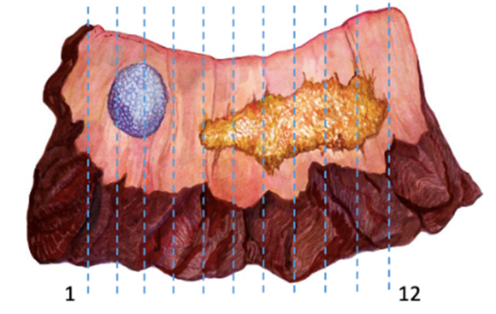
Figure 1. Foreskin vertical sectioning method in a biphasic pseudohyperlastic (right) and verrucous (left) carcinomas.
Resurfacing and Glansectomies (Figures 2 and 3)
The glans surface is marked by the surgeon into four quadrants radiating out from the meatus to the coronal sulcus. The glans mucosa is dissected out between the subepithelial tissues and corpus spongiosum although often small areas of corporal tissue are found attached to the specimen which measure 0.5-2mm in thickness (Corbishley Seminars). In glansectomies there are no special anatomical indications and sections should be made perpendicular to the tumor in sequential slices inking the deep resection margin which is usually at the level of corpus spongiosum, but a portion of the tunica albuginea may be present.

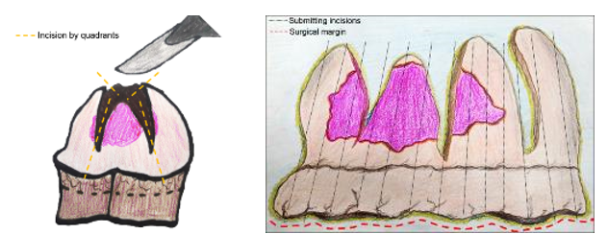
Figure 2. Resurfacing specimen (lesion indicated in purple). Glans surface incisions in quadrants before resection (A). After resection, margins are indicated in red (B). Submit tissue in sequence as indicated by the vertical lines (Courtesy of Dr. C. Corbishley).

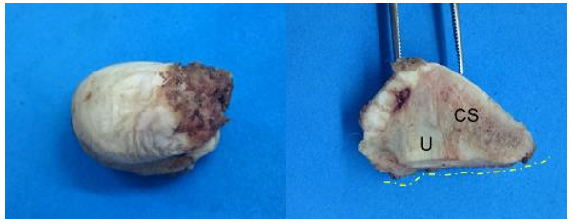
Figure 3. Glansectomy specimen. Exophytic tumor on glans surface (A). After sectioning, tumor is white with sharply delineated front (B). Histology showed a verrucous carcinoma. Corpus spongiosum (CS) and urethra (U) are not involved. Surgical margin is denoted in broken lines.

Penectomy Specimen (Figures 4 and 5)
Take measurements, describe specimen, and identify and describe tumor. Most SCCs of the penis arise from the epithelium of the distal portion of the organ (glans, coronal sulcus, and mucosal surface of the prepuce; the tumor may involve one or more of these anatomical compartments) If present, classify the foreskin as short, medium, long, and/or phimotic. Cut the proximal margin of resection en face making sure to include the entire circumference of the urethra (Figure 5). If the urethra has been retracted, it is important to identify its resection margin and submit it entirely. The resection margin can be divided into three important areas that need to be analyzed: the skin of the shaft with underlying dartos and penile fascia; corpora cavernosa with albuginea; and urethra with periurethral cylinder that includes subepithelial connective tissue (lamina propria), corpus spongiosum, albuginea, and penile fascia (Figure 5). The urethra and periurethral cylinder can be placed in one cassette. The skin of the shaft with dartos and fascia can be included together with the corpora cavernosa. Because this is a large specimen, it may need to be included in several cassettes to include the entire resection margin. Fix the rest of the specimen overnight. Then, in the fixed state and if the tumor is large and involves most of the glans, cut longitudinally and centrally by using the meatus and the proximal urethra as reference points. Do not probe the urethra. Separate the specimen into halves, left and right. Then cut two to six serial sections of each half. If the tumor is small and asymmetrically located in the dorsal or ventral area, the central portion of the tumor may be used as the axis of sectioning. If the tumor is large involving multiple sites (glans, sulcus, and foreskin), it is important not to remove the foreskin leaving the entire specimen intact for sectioning.

In cases of small carcinomas exclusively located in the glans with no foreskin involvement, one may choose to remove the foreskin leaving a 3-mm redundant edge around the sulcus. Proceed cutting the foreskin as indicated for circumcision specimens. If the primary tumor is located in the glans, one should still submit the foreskin serially and in an orderly fashion labeled from 1 to 12 clockwise. The rest of the penectomy specimen should be handled as described above.

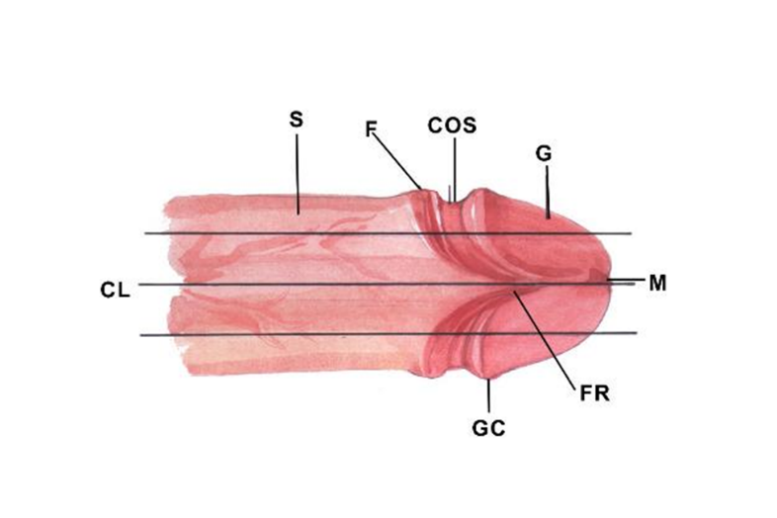
Figure 4. Partial penectomy specimen. Vertical lines indicate anatomical sites. Horizontal lines indicate sectioning method, central and sagittal. S, Shaft; F, foreskin; COS, coronal sulcus; G, glans; M, meatus; FR, frenulum; GC, glans corona; CL, center line.

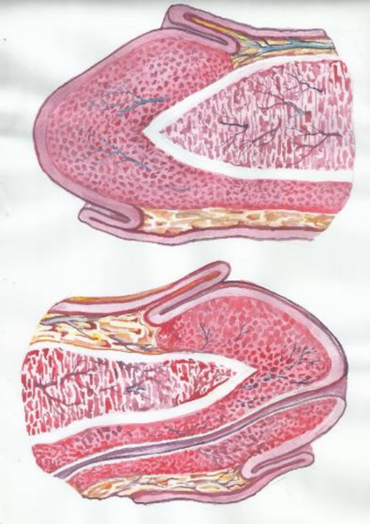
Figure 5. Cut surface of partial penectomy specimen. Above there is the sagittal cut. All anatomical layers from glans, coronal sulcus, and foreskin are grossly evident. Below is the central cut with urethra separating superior from inferior glans.
C. Types of Foreskin
There are three foreskin types (Figure 6): in the short foreskin, the preputial orifice is located behind the glans corona; in the medium foreskin, the orifice is between the corona and the meatal orifice; in the long foreskin, the entire glans is covered and the meatus is not identified without retracting the foreskin. Phimotic foreskins are unretractable and long.¹ Phimosis is present in up to one-half of patients with penile carcinoma¹, and its presence is considered a risk factor for the development of this tumor.^{2,3,4}

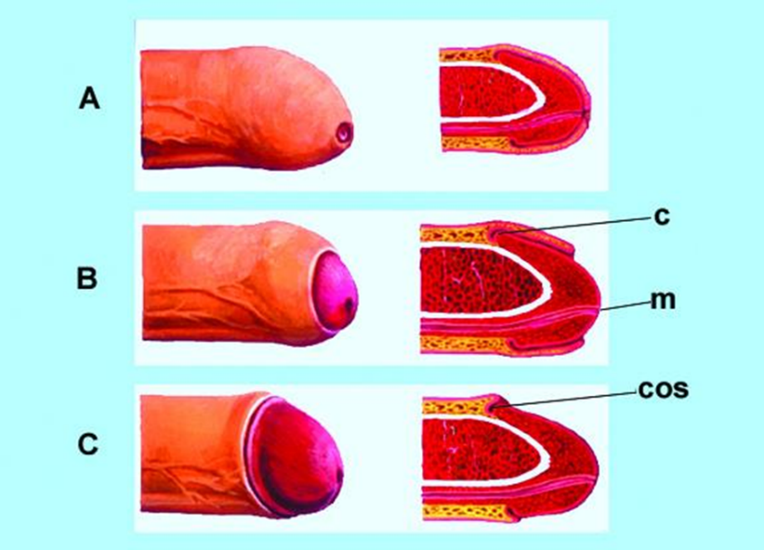
Figure 6. Types of foreskin, long (A), medium (B) and short (C). C, corona; M, meatus; COS, coronal sulcus.

References
- Velazquez EF, Bock A, Soskin A, Codas R, Arbo M, Cubilla AL. Preputial variability and preferential association of long phimotic foreskins with penile cancer: an anatomic comparative study of types of foreskin in a general population and cancer patients. Am J Surg Pathol. 2003;27(7):994-998.
- Daling J, Madeleine MM, Johnson LG, et al. Penile cancer: importance of circumcision, human papillomavirus and smoking in in situ and invasive disease. Int J Cancer. 2005;116(4):606-616.
- Tsen HF, Morgenstern H, Mack T, Peters RK. Risk factors for penile cancer: results of a population-based case-control study in Los Angeles County (United States). Cancer Causes Control. 2002;12(3):267-277.
- Madsen BS, van den Brule AJ, Jensen HL, Wholfahrt J, Frisch M. Risk factors for squamous cell carcinoma of the penis: population-based case-control study in Denmark. Cancer Epidemiol Biomarkers Prev. 2008;17(10):2683-2691.

D. Tumor Focality
Focality refers to one (unifocal) or more (multifocal) independent primary tumors in the same specimen or anatomical site. Multifocal tumors are separated by non-neoplastic tissue. A whole organ section with tridimensional reconstruction is required to qualify a tumor as multifocal. Multicentricity is a clinical or gross concept and it refers to the non-tridimensional observation of more than one tumor in the same specimen detected in routine sections. Most invasive penile carcinomas are unifocal, but about 8-10% of the cases present as multifocal lesions.¹ Primary preputial carcinomas tend to be multifocal, especially those associated with extensive lichen sclerosus. A prototype is the Pseudo-hyperplastic variant of squamous cell carcinoma (Figure 7).² Compared with invasive carcinomas, PeIN lesions are more frequently multifocal in various sites (glans, sulcus, foreskin, and/or skin of the shaft), especially those associated with HPV.^{3,4}

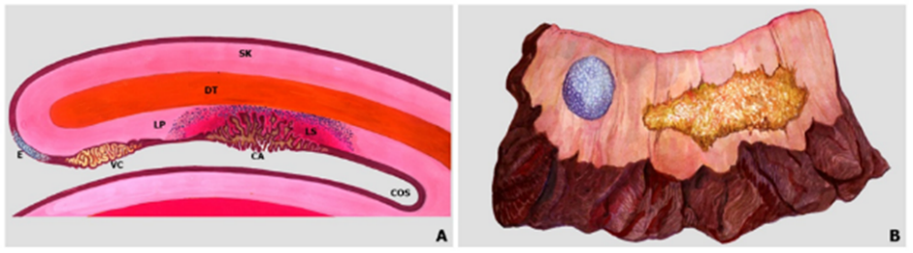
Figure 7. Multicentric tumors: pseudohyperplastic carcinoma of the foreskin (A) and verrucous carcinoma (B) associated with lichen sclerosus. SK (skin), DT (dartos), LP (lamina propria), E (epithelium with squamous hyperplasia), VC (verrucous carcinoma), CA (pseudohyperplastic carcinoma, COS (coronal sulcus).

References
- Cubilla AL, Barreto J, Caballero C, et al. Pathologic features of epidermoid carcinoma of the penis. A prospective study of 66 cases. Am J Surg Pathol. 1993;17:753-763.
- Cubilla AL, Velazquez EF, Young RH. Pseudohyperplastic squamous cell carcinoma of the penis associated with lichen sclerosus. An extremely well-differentiated, nonverruciform neoplasm that preferentially affects the foreskin and is frequently misdiagnosed: a report of 10 cases of a distinctive clinicopathologic entity. Am J Surg Pathol. 2004;28:895-900.
- Oertell J, Caballero C, Iglesias M, et al. Differentiated precursor lesions and low-grade variants of squamous cell carcinomas are frequent findings in foreskins of patients from a region of high penile cancer incidence. Histopathology. 2011;58:925-933.
- Fernandez-Nestosa MJ, Guimera N, et al. Comparison of Human Papillomavirus Genotypes in Penile Intraepithelial Neoplasia and Associated Lesions: LCM-PCR Study of 87 Lesions in 8 Patients. Int J Surg Pathol. 2020;28:265-272.

E. Tumor Site
Tumor sites are the glans, coronal sulcus, foreskin, the skin of the shaft, and penile (distal) urethra (Figure 8). Unlike urothelial tumors arising in the proximal urethra, more than half of tumors arising in the penile urethra are non-urothelial and morphologically indistinguisible from tumors originating in the glans.^{1,2} The information on tumor location is scant, variable, or not very reliable. The reasons are the lack of knowledge of penile anatomy, the lack of interest of clinicians and pathologists to precisely define the site of the tumor, the confusion of location with sites of origin, and, especially, in regions endemic for penile cancer, the large size of tumors affecting more than one site and effacing the normal boundaries of the anatomical compartments. In one prospective study, 56% of all cancer cases involved multiple compartments.³ Excluding these large neoplasms, where sites of involvement are not clear, the majority of penile squamous cell carcinomas originate in the glans (80%), foreskin (15%), or coronal sulcus (Figures 9 and 10).^{4,5,6}Tumors arising in the skin of the shaft⁷ or outer surface of the foreskin are most unusual). We have not seen tumors arising in the foreskin outer surface skin. Site of origin is not synonymous with tumors involving anatomical sites. There are tumors with superficially spreading or multicentric patterns that may affect or originate in more than one compartment.⁶ To evaluate prognosis by anatomical site, only tumors compromising one epithelial compartment should be considered.

The main reason for establishing site of tumor as a required data for the pathology report is that carcinomas exclusive of the foreskin are associated with a better prognosis than those limited to the glans. Circumcision is the most common treatment modality for carcinomas of foreskin, and recurrences were reported to be less frequent in foreskin carcinomas than in those of glans.⁸ Glans carcinomas are comparatively of higher grade, associated with HPV and with infiltration of deeper anatomical layers. Carcinomas of the foreskin are less likely to be associated with HPV than glans carcinomas, are more likely to be associated with lichen sclerosus, and show a lower frequency of regional metastasis.^{9,10}

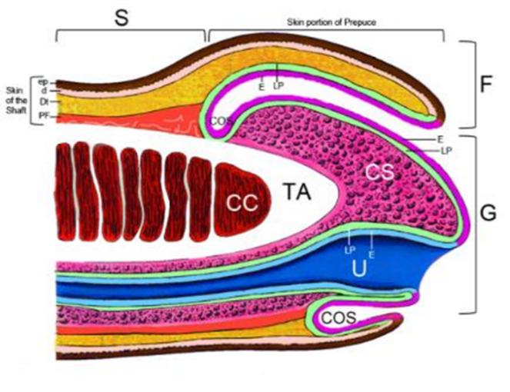
Figure 8. Anatomical Sites and Levels. Compartments: G (glans), F (foreskin), COS (coronal sulcus), S (shaft), U (urethra). Levels: E (epithelium), LP (Lamina propria), CS. (Corpus spongiosum), TA (Tunica albuginea), CC (corpus cavernosum), Dt (dartos), d (dermis), ep (epidermis), PF (penile fascia). Note the mucosal epithelium inner surface of the foreskin (in purple) in contrast with the epidermis (in brown).

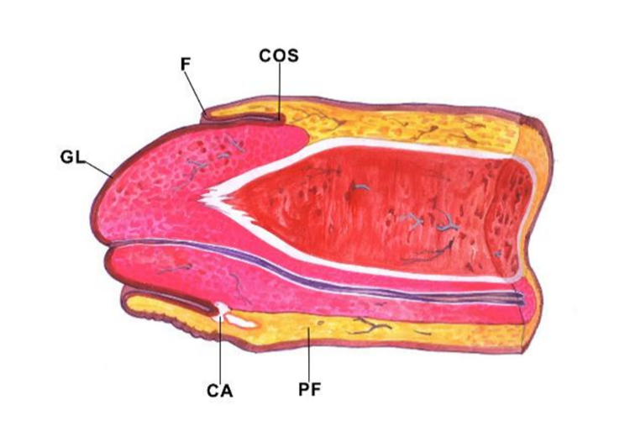
Figure 9. Tumor involving one anatomical site at the coronal sulcus (CA). GL, Glans; F, Foreskin; COS, Coronal Sulcus, PF, penile fascia.
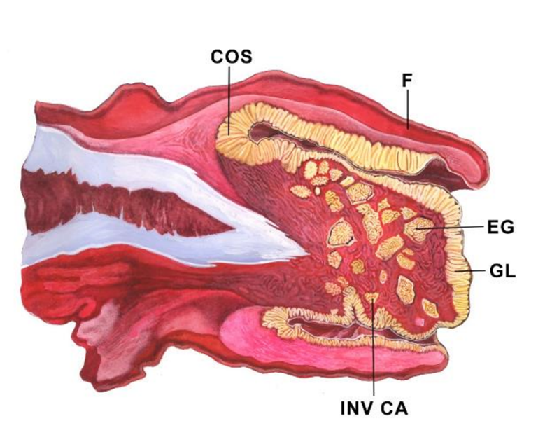
Figure 10. Tumor affecting multiple compartments. Diagrammatic representation of an exo-endophytic tumor (condylomatous-warty carcinoma) replacing the distal penis.EG, endophytic growth. Tumor involves glans (GL), coronal sulcus (COS), and foreskin inner mucosal epithelium (F).

References
- Cubilla AL, Barreto J, Caballero C, Ayala G, Riveros M. Pathologic features of epidermoid carcinoma of the penis. A prospective study of 66 cases. Am J Surg Pathol. 1993;17:753-763.
- Cubilla AL, Velazquez EF, Young RH. Pseudohyperplastic squamous cell carcinoma of the penis associated with lichen sclerosus. An extremely well-differentiated, nonverruciform neoplasm that preferentially affects the foreskin and is frequently misdiagnosed: a report of 10 cases of a distinctive clinicopathologic entity. Am J Surg Pathol. 2004;28:895-900.
- Oertell J, Caballero C, Iglesias M, et al. Differentiated precursor lesions and low-grade variants of squamous cell carcinomas are frequent findings in foreskins of patients from a region of high penile cancer incidence. Histopathology. 2011;58:925-933.
- Fernandez-Nestosa MJ, Guimera N, Sanchez DF, et al. Comparison of Human Papillomavirus Genotypes in Penile Intraepithelial Neoplasia and Associated Lesions: LCM-PCR Study of 87 Lesions in 8 Patients. Int J Surg Pathol. 2020;28;265-272.
- Epstein JI, Magi-Galluzzi C, Zhou M, Cubilla AL. Tumors of the Prostate Gland, Seminal Vesicles, Penis, and Scrotum. S.l.: American Registry of Pathology, 2020.
- Moch H, Amin MB, Berney DM, et al. The 2022 World Health Organization Classification of Tumours of the Urinary System and Male Genital Organs-Part A: Renal, Penile, and Testicular Tumours. Eur Urol. 2022.
- Moch H, Cubilla AL, Humphrey PA, et al. The 2016 WHO Classification of Tumours of the Urinary System and Male Genital Organs-Part A: Renal, Penile, and Testicular Tumours. Eur Urol. 2016;70:93-105.
- Bezerra SM, Chaux A, Ball MW, et al. Human papillomavirus infection and immunohistochemical p16(INK4a) expression as predictors of outcome in penile squamous cell carcinomas. Hum Pathol. 2015;46:532-540.
- Chahoud J, Zacharias NM, Pham R, et al. Prognostic Significance of p16 and Its Relationship with Human Papillomavirus Status in Patients with Penile Squamous Cell Carcinoma: Results of 5 Years Follow-Up. Cancers (Basel). 2022;14.
- Sand FL, Rasmussen CL, Frederiksen MH, et al. Prognostic Significance of HPV and p16 Status in Men Diagnosed with Penile Cancer: A Systematic Review and Meta-analysis. Cancer Epidemiol Biomarkers Prev. 2018;27:1123-1132.

F. Macroscopic Features
Gross features in invasive penile carcinoma are variable but, in many cases, distinctive permitting a gross diagnosis. The most common is that of an ulcerative non-exophytic tumor mass, not infrequent is the verruciform pattern observed in a third of all cases, or a superficial flat and rarely a polypoid mass. A mixed combination of these features also occurs. The common subtype of SCC usually presents with a non-exophytic ulcerated mass whereas there are various tumor subtypes presenting as verruciform, typically the verrucous, condylomatous, and papillary NOS carcinomas. Warty carcinomas have a more uniform and homogeneous micronodular appearance whereas verrucous carcinomas show an asymmetrical larger coarser nodularity. Classical or Giant condylomas may be grossly similar to condylomatous and verrucous carcinomas. Sarcomatoid carcinomas classically present as a polypoid and or necrotic and hemorrhagic mass (Figure 11).

Cut surface on a penectomy specimen may identify special tumors. The papillomatous feature with a dark central core is characteristic of warty carcinomas (Figure 12). The sharply delineated tumor front is present in giant condylomas and verrucous carcinomas (Figure 13). The ulcerating and solid beige features with minute yellow necrotic foci is seen in basaloid carcinomas. Carcinoma cuniculatum diagnosis is made on the basis of a gross tumor burrowing pattern of growth.

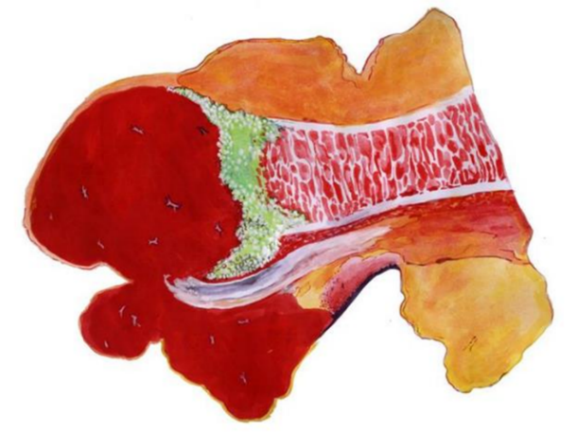
Figure 11. Polypoid necrotic and hemorrhagic sarcomatoid carcinoma. In green there is viable tumor invading corpus cavernosum after destruction of the tunica albuginea.

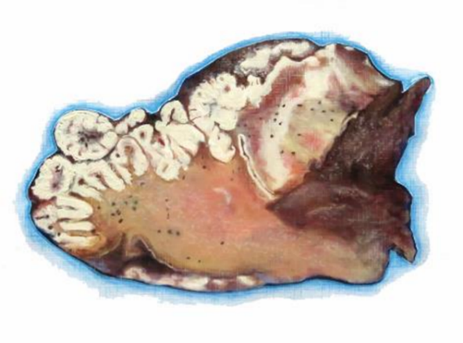
Figure 12. Cut surface of warty (condylomatous) carcinoma involving glans and foreskin.
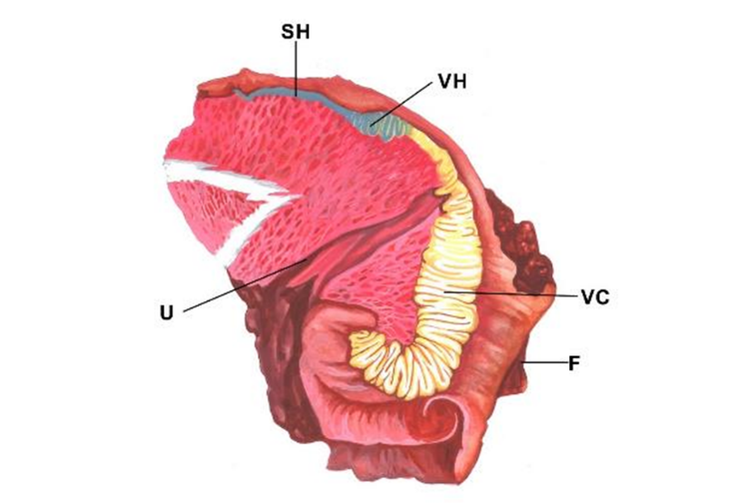
Figure 13. Cut surface of verrucous carcinoma (VC) of glans. VH, verrucous hyperplasia; SH, squamous hyperplasia; U, urethra; F, Foreskin.

G. Tumor Size
Gross tumor measurement in penile carcinomas may be done in three dimensions in cm but measuring the maximum diameter should suffice. The TNM staging system does not consider the size of penile tumors as an important criterion for classification. Metastasizing and non-metastasizing tumors are of similar size in some studies but not in all.^{1,2} Tumors diagnosed in tropical developing countries tend to be larger and more invasive than those from northern countries indicating a higher stage at diagnosis.

The apparent lack of correlation between tumor size and nodal spread or patients’ outcome may be due to the inclusion of verruciform and non-verruciform tumors as one group in the studies evaluating prognosis. Verruciform carcinomas (verrucous, papillary NOS, and warty [condylomatous]) are rarely associated with metastasis, irrespective of their size. Cuniculatum carcinoma, among the largest penile carcinomas, are not associated with regional or distant spread.³ These neoplasms comprise at least a third of all penile tumors and are usually of large size, in fact significantly larger than other types of squamous cell carcinomas of the penis except the sarcomatoid variant. Tumor size may be a significant prognostic marker when verruciform neoplasms are excluded from the evaluation. We found no studies specifically addressing this approach of size evaluation.

References
- Guimaraes GC, Cunha IW, Soares FA, et al. Penile squamous cell carcinoma clinicopathological features, nodal metastasis and outcome in 333 cases. J Urol. 2009;182:528-534.
- Kawase M, Takagi K, Kawada K, et al. Clinical Lymph Node Involvement as a Predictor for Cancer-Specific Survival in Patients with Penile Squamous Cell Cancer. Curr Oncol. 2022;29:5466-5474.
- Barreto JE, Velazquez EF, Ayala E, et al. Carcinoma cuniculatum: a distinctive variant of penile squamous cell carcinoma: report of 7 cases. Am J Surg Pathol. 2007;31:71-75.

H. Histologic Subtype of Squamous Cell Carcinoma
The World Health Organization (WHO) classification of tumors of the penis was recently published.¹ Most penile cancers are squamous cell carcinomas (SCC), and most arise from the epithelium of the distal portion of the penis (including glans, coronal sulcus, and mucosal surface of the foreskin). Squamous cell carcinoma of the usual type (keratinizing SCC) comprises about 50% to 60% of all cases.^{2,3,4} There are other SCC subtypes showing distinctive morphological and outcome features.^{3,4,5} The different histological subtypes correlate with different rates of regional/nodal and systemic dissemination.
Squamous cell carcinoma are broadly defined as HPV-associated and HPV-independent. If ancillary studies to make that distinction are not available, “Squamous cell carcinoma NOS” can be used. The latest WHO edition aimed at simplifying the squamous cell carcinoma subtypes by grouping distinct morphologic subtypes which have similar behavior and pathogenesis, under one encompassing parent subtype. For example, pseudohyperplastic and acantholytic/ pseudoglandular patterns are eclipsed under HPV-independent squamous cell carcinoma of the usual type. Similarly, carcinoma cuniculatum is included in verrucous carcinoma. When more than one histologic pattern is present, using “mixed” subtype and specifying the different histologies is encouraged. Unusual HPV-positive poorly differentiated carcinomas with tumor-associated inflammatory cells and medullary features have been reported.⁵

Penile cancer subtypes can be prognostically stratified into three groups. The low-risk group includes verruciform tumors such as verrucous, papillary, and warty/condylomatous carcinomas.^{6,7} More recently described histologic patterns, such as pseudohyperplastic and carcinoma cuniculatum of the penis, also belong to this category of excellent prognosis.^{8,9}The high-risk category is comprised of basaloid, sarcomatoid, adenosquamous, and poorly differentiated SCC of the usual type.^{10,11,12}There is an intermediate category of metastatic risk that includes most SCCs of the usual type, some mixed neoplasms (such as hybrid verrucous carcinomas), and high-grade variants of warty/condylomatous carcinomas.⁷

References
- Moch H, Amin MB, Berney DM, et al. The 2022 World Health Organization Classification of Tumours of the Urinary System and Male Genital Organs-Part A: Renal, Penile, and Testicular Tumours. Eur Urol. 2022.
- Epstein JH, Humphrey PA, Cubilla AL. Tumors of the Prostate Gland, Seminal Vesicles, Male Urethra, Penis and Scrotum. Washington, DC: Armed Forces Institute of Pathology; 2011 Atlas of Tumor Pathology.
- Cubilla AL, Dillner J, Schellhammer PF, Horenblas S. Malignant epithelial tumors. In: Eble JN, Sauter G, Epstein J, Sesterhenn I, eds. Pathology and Genetics of Tumors of the Urinary System and Male Genital Organs. Lyon, France: IARC Press; 2004. World Health Organization Classification of Tumours.
- Velazquez EF, Barreto JE, Ayala G, Cubilla AL. Penis. In: Mills SE, Carter D, Greenson JK, et al, eds. Sternberg’s Diagnostic Surgical Pathology. 5th ed. Philadelphia, PA: Lippincot Williams & Wilkins; 2009.
- Canete-Portillo S, Clavero O, Sanchez DF, et al. Medullary Carcinoma of the Penis: A Distinctive HPV-related Neoplasm: A Report of 12 Cases. Am J Surg Pathol. 2017;41:535-540.
- Cubilla AL, Reuter V, Velazquez E, Piris A, Saito S, Young RH. Histologic classification of penile carcinoma and its relation to outcome in 61 patients with primary resection. Int J Surg Pathol. 2001;9:111-120.
- Cubilla AL, Velazques EF, Reuter VE, Oliva E, Mihm MC Jr, Young RH. Warty (condylomatous) squamous cell carcinoma of the penis: a report of 11 cases and proposed classification of verruciform tumors penile tumors. Am J Surg Pathol. 2000;24:505-512.
- Cubilla AL, Velazquez EF, Young RH. Pseudohyperplastic squamous cell carcinoma of the penis associated with lichen sclerosus — an extremely well-differentiated nonverruciform neoplasm that preferentially affects the foreskin and is frequently misdiagnosed: a report of 10 cases of a distinctive clinicopathologic entity. Am J Surg Pathol. 2004;28:895-900.
- Barreto JE, Velazquez EF, Ayala E, Torres J, Cubilla AL. Carcinoma cuniculatum of the penis — a distinctive variant of penile squamous cell carcinoma: report of 7 cases. Am J Surg Pathol. 2007;31:71-75.
- Cubilla AL, Reuter VE, Gregoire L, et al. Basaloid squamous cell carcinoma: a distinctive HPV related penile neoplasm: a report of 20 cases. Am J Surg Pathol. 1998;22:751-761.
- Velazquez EF, Melamed J, Barreto JE, Aguero F, Cubilla AL. Sarcomatoid carcinoma of the penis: a clinico-pathological study of 14 cases. Am J Surg Pathol. 2005;29:1152-1158.
- Cubilla AL, Ayala MT, Barreto JE, Bellasai JG, Nöel JC. Surface adenosquamous carcinoma of the penis: a report of three cases. Am J Surg Pathol. 1996;20:156-160.

I. Verruciform Tumors (special consideration)
Verruciform neoplasms of the penis are a heterogenous group of benign or low-grade malignant exophytic tumors representing about a third of all penile malignant tumors and due to confusing older literature, most problematic to diagnose. Some of them are non-HPV related and others are HPV related. They are Verrucous carcinoma, warty (condylomatous) carcinoma, papillary carcinoma NOS and typical and giant condylomas (Buschke-Lowenstein tumor) and their mixtures or variants. The differential diagnosis may be challenging to the inexperienced pathologist but there are distinctive features to help delineate in Figure 14.

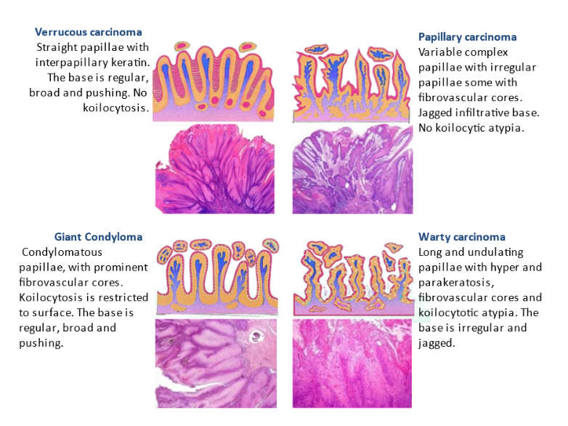
Figure 14. Verruciform tumors: Diagrammatic representation and histology of common verruciform tumors.

J. Histologic Grade
Histological grade has been consistently reported as an influential predictive factor of groin metastasis and dissemination of penile cancer.^{1,2,3} We recommend a method to grade penile SCCs as follows:
- Grade 1 is an extremely well-differentiated carcinoma, with a minimal deviation from the morphology of normal/hyperplastic squamous epithelium.
- Grade 2 tumors show a more disorganized growth as compared to grade 1 lesions, higher nuclear-to-cytoplasmic ratio, evident mitoses, and, although present, less prominent keratinization.
- Grade 3 are tumors showing any proportion of anaplastic cells, identified as solid sheets or irregular small aggregates, cords or nests of cells with little or no keratinization, high nuclear-to-cytoplasmic ratio, thick nuclear membranes, nuclear pleomorphism, clumped chromatin, prominent nucleoli, and numerous mitosis.^{3,4}

A tumor should be graded according to the least differentiated component. Any proportion of grade 3 should be noted in the report.⁴

References
- Slaton JW, Morgenstern N, Levy DA, et al. Tumor stage, vascular invasion and the percentage of poorly differentiated cancer: independent prognosticators for inguinal node metastasis in penile squamous cancer. J Urol. 2001;165:1138-1142.
- Cubilla AL, Velazquez EF, Ayala GE, et al. Identification of prognostic pathologic parameters in squamous cell carcinoma of the penis: significance and difficulties. Pathol Case Rev. 2005;10:3-13.
- Velazquez EF, Ayala G, Liu H, et al. Histologic grade and perineural invasion are more important than tumor thickness as predictor of nodal metastasis in penile squamous cell carcinoma invading 5 to 10 mm. Am J Surg Pathol. 2008;32:974-979.
- Chaux A, Torres J, Pfannl R, et al. Histologic grade in penile squamous cell carcinoma: visual estimation versus digital measurement of proportions of grades, adverse prognosis with any proportion of grade 3 and correlation of a Gleason-like system with nodal metastasis. Am J Surg Pathol. 2009;33:1042-1048.

K. Thickness/Depth of Invasion
The tumor depth in small lesions is best obtained by perpendicularly sectioning along the tumor's central axis. For large glans tumors, it is preferred to section the specimen longitudinally in half, with additional parallel sections of each half, using as an axis the central and ventral penile urethra. The depth of invasion of SCC is defined as a measurement in millimeters from the epithelial-stromal junction of the adjacent nonneoplastic epithelium to the deepest point of invasion. In larger tumors, especially verruciform ones, the previously mentioned system is not applicable, and we measure the thickness from the surface (excluding the keratin layer) to the deepest point of invasion (Figure 15). Depth of invasion and tumor thickness are of equivalent significance.

There is a correlation between depth of invasion and outcome in penile cancers. Minimal risk for metastasis was reported for tumors measuring less than 5 mm in thickness.^{1,2}Tumors invading deeper into penile anatomical levels are usually associated with a higher risk for nodal involvement. There is also a correlation between deeper infiltration and higher histological grade, although some exceptions do occur.³Tumors invading corpus cavernosum are at higher risk for nodal metastases than those invading only corpus spongiosum,^{3,4} and the deepest erectile tissue invaded should be clearly stated in the final pathology report. Per AJCC 8 edition, tumor invading into subepithelial connective tissue (lamina propria), Dartos muscle, and Buck’s fascia is staged as T1; tumor invading into corpus spongiosum (either glans or ventral shaft) with or without urethral invasion is staged as T2; tumor invading into corpora cavernosum (including tunica albuginea) with or without urethral invasion is staged as T3; and tumor invading into adjacent structures (i.e., scrotum, prostate, pubic bone) is staged as T4.

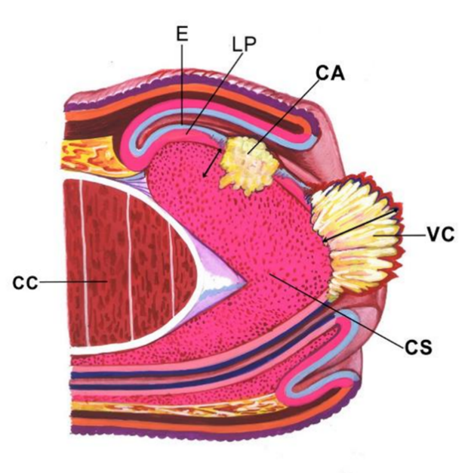
Figure 15. Methods for measurement for non-verruciform and verruciform tumors. CA represents depth of invasion in a usual squamous cell carcinoma invading corpus spongiosum (CS). VC represents thickness of a verrucous carcinoma (VC) with a broadly based invasive front. CC, corpus cavernosum.

References
- Velazquez EF, Ayala G, Liu H, et al. Histologic grade and perineural invasion are more important than tumor thickness as predictor of nodal metastasis in penile squamous cell carcinoma invading 5 to 10 mm. Am J Surg Pathol. 2008;32:974-979.
- Emerson RE, Ulbright TM, Eble JN, et al. Predicting cancer progression in patients with penile squamous cell carcinoma: the importance of depth of invasion and vascular invasion. Mod Pathol. 2001;14:963-968.
- Leijte J, Gallee M, Antonini N, et al. Evaluation of current TNM classification of penile carcinoma. J Urol. 2008;180:933-938.
- Chaux A, Caballero C, Soares F, et al. The prognostic index: a useful pathologic guide for prediction of nodal metastases and survival in penile squamous cell carcinoma. Am J Surg Pathol. 2009;33:1049-1057.

L. Tumor Base of Infiltration
Two patterns are recognized: infiltrating (invasion in blocks of small solid strands of cell tumors broadly infiltrating the stroma) and pushing infiltration (tumor cells invading in large cell blocks with well-defined tumor-stroma interface). The infiltrating pattern of invasion is associated with a higher risk for nodal involvement.¹

References
- Guimarães G, Lopes A, Campos RS, et al. Front pattern of invasion in squamous cell carcinoma of the penis: new prognostic factor for predicting risk of lymph node metastases. Urology. 2006;68:148-153.

M. Tumor Deep Borders
There has been some confusion in the reporting of the deep border of invasion or tumor front. Along the staging models, terminologies were not always sufficiently clear to communicate pathological facts. This resulted in a lack of precision and consensus in the definition of terms such as invasive vs. non-invasive and localized vs. non-localized cancers. With the purpose of clarification, we are suggesting four features or patterns of tumor growth and invasion in relation to current staging¹: 1. Non-invasive, 2. Invasive, broadly-based non-destructive, 3. Invasive, destructive but well-delineated front en bloc, 4. Invasive, destructive, irregular, finger-like front.

1. Non-invasive neoplasm: it is a tumor growing above the level of the squamous epithelium, sparing lamina propria of glans, coronal sulcus, and foreskin or shaft dermis (Figure 16 A). A non-invasive neoplasm is like an in situ lesion but is especially applied to exophytic or bulkier clinically evident tumor growing above the level of the basal cell layer. All lesions growing at or above the level of the basal epithelium are staged as pTa.

2. Invasive (localized) neoplasm with a broadly-based pushing tumor front: the tumor grows into lamina propria or corpus spongiosum or deeper, it is solid without separated nests and the interface between neoplasm and stroma is regular and broadly based. The growth may be in ample sheets or in scalloped undulating borders (Figure 16 B). Whereas there was some disagreement in the nomenclature of broadly-based tumors being invasive or non-invasive, most of our colleagues now consider broadly-based invasion to any tumor growing beyond the limits of the basal layer squamous epithelia into lamina propria. What is clinically important is the fact that differentiated tumors either non-invasive (in situ) or invasive but with a sharply delineated broadly-based tumor front have no risk of regional metastasis. Applying strictly current terminology these broadly-based but invasive tumors should be staged at least as pT1 and/or according to their anatomical level of invasion, which in case of verrucous carcinomas may be quite deep. However, analogically to bladder pTa tumors pushing into lamina propia with a broad-base, these rare tumors may still be considered, albeit technically invasive, as localized. It is our opinion that since they have no metastatic potential, independent of their level of invasion, they should be classified as pTa.

3. Invasive neoplasm with a destructive irregular front but en bloc, well-delineated margins: Front of invasion is not broadly-based but destructive, albeit there is a well-delineated border between tumor and stroma (Figure 16 C). Lamina propria and deeper anatomical levels are compromised. This pattern of invasion, described by Aita et al was found to be associated with better prognosis comparing with irregular finger-like invasion.² It is validated and it is part of a recently proposed predictive scoring index for penile cancer.^{3,4} Tumors with these features are staged as at least pT1.

4. Invasive neoplasm with an irregular/destructive finger-like tumor front: the limits of tumor and the stroma are irregular, destructive, finger-like. Lamina propria or deeper anatomical levels are compromised by the tumors (Figure 16 D). Tumors in this stage of invasion are classified as at least pT1.

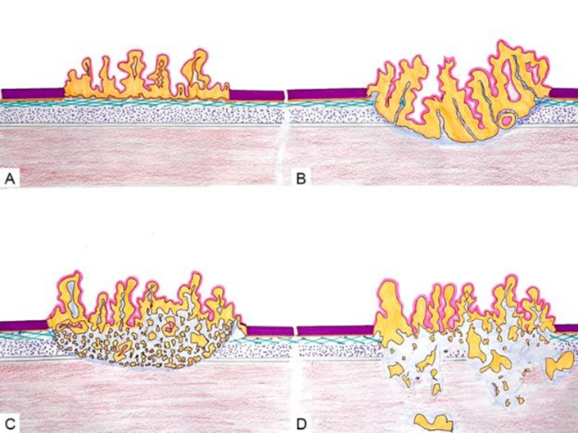
Figure 16. Patterns of invasion. Non-invasive neoplasm (A). Invasive (localized) (B) neoplasm with a broadly-based pushing tumor front. Invasive neoplasm with a destructive irregular front but en bloc, well-delineated margins (C). Invasive neoplasm with an irregular/destructive finger-like tumor front (D).

References
- Sanchez DF, Fernandez-Nestosa MJ, Canete-Portillo S, et al. What Is New in the Pathologic Staging of Penile Carcinoma in the 8th Edition of AJCC TNM Model: Rationale for Changes With Practical Stage-by-stage Category Diagnostic Considerations. Adv Anat Pathol. 2021;28:209-227.
- Guimaraes GC, Lopes A, Campos RS, et al. Front pattern of invasion in squamous cell carcinoma of the penis: new prognostic factor for predicting risk of lymph node metastases. Urology. 2006; 68;148-153.
- Menon H, Patel RR, Ludmir EB, et al. Local management of preinvasive and clinical T1-3 penile cancer: utilization of diverse treatment modalities. Future Oncol. 2020;16:955-960.
- Sali AP, Menon S, Murthy V, et al. A Modified Histopathologic Staging in Penile Squamous Cell Carcinoma Predicts Nodal Metastasis and Outcome Better Than the Current AJCC Staging. Am J Surg Pathol. 2020;44;1112-1117.

N. Tumor Extent
The anatomy of the penis is complex and there are distinctive anatomical sites with variable tissue layers composition.¹ Tumors may in an exclusive manner originate in the glans, the foreskin, the coronal sulcus or the shaft, in this order of frequency. Not uncommonly, especially in specimens from patients from southern tropical countries, large tumors involve more than one site. Superficially spreading carcinomas may horizontally grow affecting more than one site (Figure 17).² Tumors of the foreskin tend to be better differentiated and associated with lichen sclerosus, carrying a better prognosis than those exclusive of the glans. For this reason, is recommended to evaluate tumor extension according to separate anatomical sites.

In the glans, tissue layers for tumor invasion are lamina propria, corpus spongiosum, tunica albuginea and corpus cavernosum. The tunica is part of the corpus cavernosum. In the foreskin the layers are lamina propria, dartos and skin (dermis and epidermis) (Figure 18).¹ In the shaft, a recent evaluation of primary tumors exclusive of this site observed the following layers in relation to tumor invasion: skin, dartos, penile (Buck) fascia, tunica albuginea and corpus cavernosum (Figure 19).³ Tumors primary at the sulcus are very rare and we did not find a histological evaluation of tumor invasion of this site according to anatomical layers.

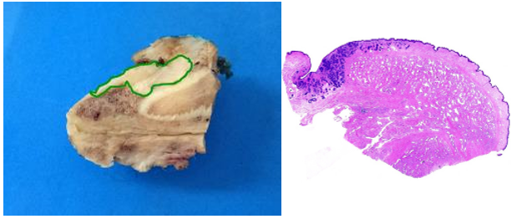
Figure 17. Tumor extension. Extension of tumor (in green) from glans to penile fascia (A). Lamina propria spread (B): Tumor growths along the lamina propria in glans, coronal sulcus and foreskin.

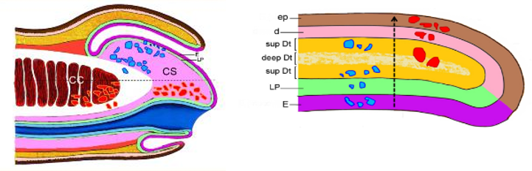
Figure 18. Extent, anatomical levels of invasion. Carcinomas of Glans: Each spot represents one case invading a specific anatomical level. Cases above the broken horizontal line (in blue) had negative inguinal nodes. Cases below the line (in red) had positive nodes. Carcinomas exclusive of the Foreskin: Tumor invasion is from inner mucosa to skin (arrow). Blue and red spots indicate tumor deepest invasion point by anatomical level.

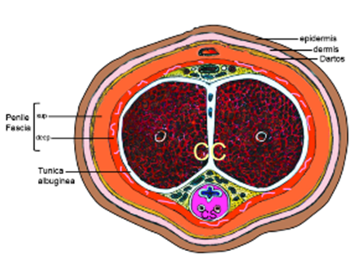
Figure 19. Cross section of penile shaft. Anatomical levels from Surface to Deep: epidermis, dermis, dartos, penile (Buck) fascia, tunica albuginea and corpus cavernosum.

References
- Velazquez EF, Barreto JE, Canhete-Portillo S, Cubilla AL. Penis and Distal Urethra. In: Mills SE, ed. Histology for Pathologists. Wolters Kluwer, 2020;1009-1028.
- Cubilla AL, Barreto J, Caballero C, et al. Pathologic features of epidermoid carcinoma of the penis. A prospective study of 66 cases. Am J Surg Pathol. 1993;17:753-763.
- Tekin B, Guo R, Cheville JC, Canete-Portillo S, et al. Penile squamous cell carcinoma exclusive to the shaft, with a proposal for a novel staging system. Hum Pathol. 2023;134:92-101.

O. Lymphatic and/or Vascular Invasion
Vascular invasion, lymphatic or venous, adversely affects prognosis of penile cancer.^{1,2,3,4,5}The TNM staging classification in the 8th edition of the AJCC Cancer Staging Manual subdivides T1 tumors into T1a and T1b based on the absence or presence of lymphatic and/or vascular invasion or poorly differentiated tumors.⁶ Embolic involvement of lymphatic vascular spaces occurs usually near the invasive tumor front, but it may also be found at a certain distance from the primary tumor in anatomical areas such as the lamina propria, penile fascia, and especially in the subepithelial connective tissues surrounding penile urethra. Venous invasion indicates a more advanced stage of the disease and is related to the compromise of the specialized erectile venous structures of corpora spongiosa and cavernosa.

References
- Lopes A, Hidalgo GS, Kowalski LP, et al. Prognostic factors in carcinoma of the penis: multivariate analysis of 145 patients treated with amputation and lymphadenectomy. J Urol. 1996;156:1637-1642.
- Ficarra V, Zattoni F, Cunisco SC, et al. Lymphatic and vascular embolizations are independent predictive variables of inguinal node involvement in patients with squamous cell carcinoma of the penis: Gruppo Uro-Oncologico del Nord Est (Northeast Uro-Oncological Group) Penile Cancer data base data. Cancer. 2005;103:2507-2516.
- Ficarra V, Zattoni F, Artibani W, et al; GUONE Penile Cancer Project Members. Nomogram predictive of pathological inguinal lymph node involvement in patients with squamous cell carcinoma of the penis. J Urol. 2006;175:1700-1705.
- Kattan MW, Ficarra V, Artibani W, et al; GUONE Penile Cancer Project Members. Nomogram predictive of cancer specific survival in patients undergoing partial or total amputation for squamous cell carcinoma of the penis. J Urol. 2006;175:2103-2108.
- Novara G, Galfano A, De Marco V, et al. Prognostic factors in squamous cell carcinoma of the penis. Nat Clin Pract Urol. 2007;4:140-146.
- Amin MB, Edge SB, Greene FL, et al, eds. AJCC Cancer Staging Manual. 8th ed. New York, NY: Springer; 2017.

P. Nomograms, Risk Groups, and Perineural Invasion
An evaluation of clinical and pathological variables using a nomogram was recently developed.¹ The selected factors were clinical stage of lymph nodes, microscopic growth pattern, grade, vascular invasion, and invasion of corpora spongiosa and cavernosa and urethra. The probability of nodal metastasis as predicted by the nomogram was close to the real incidence of metastasis observed at follow-up. A second nomogram to estimate predictions of survival at 5 years with the same clinical and pathological factors gave similar results.²

More recently, perineural invasion and histological grade were found to be the strongest independent predictors of mortality in penile tumors 5 to 10 mm thick. A nomogram considering the predictive value of perineural invasion and histological grade was accordingly constructed.³ Risk groups stratification systems are available to predict the likelihood of inguinal nodal involvement and for therapeutic planning and are based on a combination of histological grade and pT stage.^{4,5,6,7} Strongest predictive power results from the combination of histological grade, deepest anatomical level of infiltration, and presence of perineural invasion. These factors are used for constructing the prognostic index.⁸

References
- Ficarra V, Zattoni F, Artibani W, et al; GUONE Penile Cancer Project Members. Nomogram predictive of pathological inguinal lymph node involvement in patients with squamous cell carcinoma of the penis. J Urol. 2006;175:1700-1705.
- Kattan MW, Ficarra V, Artibani W, et al; GUONE Penile Cancer Project Members. Nomogram predictive of cancer specific survival in patients undergoing partial or total amputation for squamous cell carcinoma of the penis. J Urol. 2006;175:2103-2108.
- Cubilla AL, Velazquez EF, Ayala GE, et al. Identification of prognostic pathologic parameters in squamous cell carcinoma of the penis: significance and difficulties. Pathol Case Rev. 2005;10:3-13.
- Solsona E, Iborra I, Rubio J, et al. Prospective validation of the association of local tumor stage and grade as a predictive factor for occult lymph node micrometastasis in patients with penile carcinoma and clinically negative inguinal lymph nodes. J Urol. 2001;165:1506-1509.
- Solsona E, Algaba F, Horenblas S, et al. EAU guidelines on penile cancer. Eur Urol. 2004;46:1-8.
- Hungerhuber E, Schlenker B, et al. Risk stratification in penile carcinoma: 25-year experience with surgical inguinal lymph node staging. Urology. 2006;68:621-625.
- Ornellas AA, Nóbrega BL, Wei Kin Chin E, et al. Prognostic factors in invasive squamous cell carcinoma of the penis: analysis of 196 patients treated at the Brazilian National Cancer Institute. J Urol. 2008;180:1354-1359.
- Chaux A, Caballero C, Soares F, et al. The prognostic index: a useful pathologic guide for prediction of nodal metastases and survival in penile squamous cell carcinoma. Am J Surg Pathol. 2009;33:1049-1057

Q. Resection Margins
Positive margins adversely affect prognosis in patients with penile squamous cell carcinomas.^{1,2,3} Important margins to be examined in partial penectomy specimens include: (1) proximal urethra and surrounding periurethral cylinder consisting of epithelium, subepithelial connective tissue (lamina propria), corpus spongiosum, and penile fascia; (2) proximal shaft with corresponding corpora cavernosa separated and surrounded by the tunica albuginea and Buck’s fascia; and (3) skin of shaft with underlying corporal dartos⁴ (Figure 20 and 21). The coronal sulcus mucosal margin and cutaneous margin should be entirely examined when evaluating circumcision specimens.

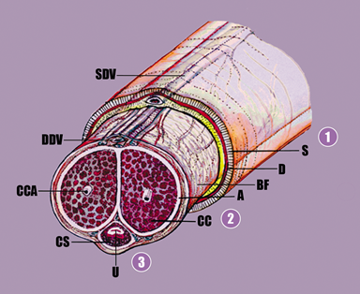
Figure 20. Partial penectomy specimen; anatomical structures of proximal resection margin. The ventral urethra (U) is surrounded by the corpus spongiosum (CS) and a delicate white tunica albuginea (A). The latter is also surrounding the corpora cavernosa (CC). The penile fascia (Buck’s fascia) (BF) is located underneath skin (S) and dartos (D). The proximal margin of resection should be cut en face and all the structures including the entire circumference of the urethra with periurethral cylinder should be examined.The 3 important margins to be examined include (1) skin of the shaft with underlying dartos and penile fascia, (2) the corpora cavernosa with surrounding tunica albuginea, and (3) the urethra and periurethral cylinder that includes the lamina propria, corpus spongiosum, albuginea, and penile fascia. Abbreviations: CCA, cavernous artery; DDV, deep dorsal vein; SDV, superficial dorsal vein.

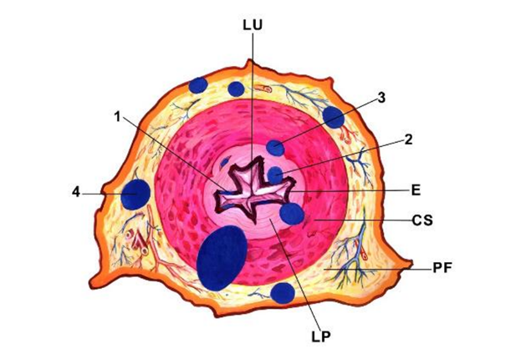
Figure 21. Urethral margin. Common sites of positive urethral margin of resection are indicated by the blue dots: 1. Intraepithelial, 2. lamina propria, 3. lymphatic vessels-corpus spongiosum and 4. Penile fascia. LU, lumen; E, epithelium; CS: corpus spongiosum; PF, penile fascia.

References
- Epstein JH, Humphrey PA, Cubilla AL. Tumors of the Prostate Gland, Seminal Vesicles, Male Urethra, Penis and Scrotum. Washington, DC: Armed Forces Institute of Pathology; 2011 Atlas of Tumor Pathology.
- Velazquez EF, Barreto JE, Ayala G, Cubilla AL. Penis. In: Mills SE, Carter D, Greenson JK, et al, eds. Sternberg’s Diagnostic Surgical Pathology. 5th ed. Philadelphia, PA: Lippincot Williams & Wilkins; 2009.
- Velazquez EF, Soskin A, Bock A, et al. Positive resection margins in partial penectomies: sites of involvement and proposal of local routes of spread of penile squamous cell carcinoma. Am J Surg Pathol. 2004;28:384-389.
- Chaux A, Caballero C, Soares F, et al. The prognostic index: a useful pathologic guide for prediction of nodal metastases and survival in penile squamous cell carcinoma. Am J Surg Pathol. 2009;33:1049-1057.

R. Number of Involved Lymph Nodes and Extension of the Lymphadenectomy
The presence of more than two positive lymph nodes in one inguinal basin increases the likelihood of contralateral inguinal and ipsilateral pelvic nodal involvement.¹ In such cases, prophylactic contralateral inguinal and ipsilateral pelvic lymphadenectomy is advised. Any pelvic lymph node involvement or extracapsular extension of any regional lymph node (inguinal or pelvic) is staged N3. The number and percentage of positive nodes involved also has an impact on survival.^{2,3}

References
- Lont AP, Kroon BK, Gallee MP, et al. Pelvic lymph node dissection for penile carcinoma: extent of inguinal lymph node involvement as an indicator for pelvic lymph node involvement and survival. J Urol. 2007;177:947-952.
- Svatek RS, Munsell M, Kincaid JM, et al. Association between lymph node density and disease specific survival in patients with penile cancer. J Urol. In press.
- Pandey D, Mahajan V, Kannan RR. Prognostic factors in node-positive carcinoma of the penis. J Surg Oncol. 2006;93:133-138.

S. Distant Metastasis
Penile carcinoma is a potentially lethal disease. It is considered a loco-regional disease in early stages but wide dissemination may occur. Liver, heart, lungs, and non-regional lymph nodes are the most common sites of involvement at autopsy.¹ Notoriously, the heart is a common site of penile cancer metastasis (Figure 22).^{2,3}

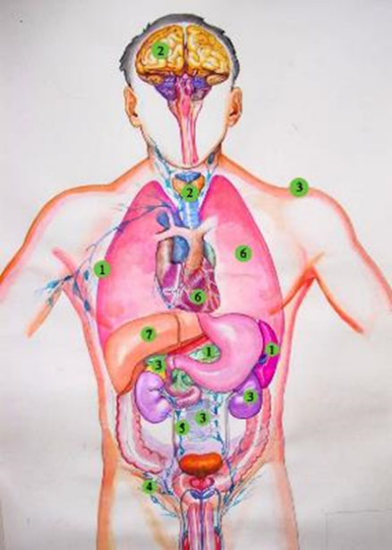
Figure 22. Sites of metastasis in an autopsy study of 14 patients. Liver, heart, and lungs are the most common sites.

References
- Chaux A, Reuter V, Lezcano C, et al. Autopsy findings in 14 patients with penile squamous cell carcinoma. Int J Surg Pathol. 2011;19:164-169.
- Nishino A, Nagai Y, Hanai T, et al. [A Case of Autopsy of Sarcomatoid Carcinoma of the Penis with Metastasis to the Right Ventricle of the Heart]. Hinyokika Kiyo. 2018;64:455-458.
- Siqueira SAC, Tomikawa CS. Intracardiac metastasis of squamous cell carcinoma of the penis. Autops Case Rep. 2013;3:23-28.

T. TNM Staging Classification
The protocol recommends the use of the TNM staging system of the American Joint Committee on Cancer (AJCC) for carcinoma of the penis.¹ By AJCC convention, the designation T refers to a primary tumor that has not been previously treated. The symbol p refers to the pathologic classification of the TNM, as opposed to the clinical classification, and is based on gross and microscopic examination. pT entails a resection of the primary tumor or a biopsy adequate to evaluate the highest pT category, pN entails removal of nodes adequate to validate lymph node metastasis, and pM implies microscopic examination of distant lesion. Pathologic staging is usually performed after surgical resection of the primary tumor. The summary of changes in the TNM staging classification in the 8th edition of the AJCC Cancer Staging Manual is as follows:

Change | Details of Change
Histologic Grade (G) | The 3-tiered World Health Organization (WHO)/International Society of Urological Pathology (ISUP) grading system has been adopted. Any proportion of anaplastic cells is sufficient to categorize a tumor as grade 3.
Definition of Primary Tumor (T) | Ta definition is now broadened to include noninvasive localized squamous carcinoma.
Definition of Primary Tumor (T) | T1a and T1b have been separated by an additional prognostic indicator-the presence or absence or perineural invasion.
Definition of Primary Tumor (T) | T1a or T1b are described by the site where they occur on the penis and are designated glans, foreskin, or shaft. Anatomic layers invaded are described for the three locations.
Definition of Primary Tumor (T) | T2 definition includes corpus spongiosum invasion.
Definition of Primary Tumor (T) | T3 definition now involves corpora cavernosum invasion.
Definition of Regional Lymph Nodes (N) | pN1 is defined as ≤2 unilateral inguinal metastases, no extranodal extension.
Definition of Regional Lymph Nodes (N) | pN2 is defined as ≥3 unilateral inguinal metastases or bilateral metastases.

Additional Descriptor
The m suffix indicates the presence of multiple primary tumors and is recorded in parentheses, e.g., pTa(m)N0M0.
Anatomic Stage/Prognostic Groups
Group T N M
Stage 0is Tis N0 M0
Stage 0a Ta N0 M0
Stage I T1a N0 M0
Stage IIA T1b N0 M0
Stage IIA T2 N0 M0
Stage IIB T3 N0 M0
Stage IIIA T1-3 N1 M0
Stage IIIB T1-3 N2 M0
Stage IV T4 Any N M0
Stage IV Any T N3 M0
Stage IV Any T Any N M1

Prognostic Factors (Site-Specific Factors)
Factors required for staging: None

Clinically significant factors:
- Involvement of corpus spongiosum
- Involvement of corpus cavernosum
- Percentage of tumor that is poorly differentiated
- Verrucous carcinoma depth of invasion
- Size of largest lymph node metastasis
- Extranodal/extracapsular extension
- Human papillomavirus (HPV) status

References
- Amin MB, Edge SB, Greene FL, et al, eds. AJCC Cancer Staging Manual. 8th ed. New York, NY: Springer; 2017.

U. Penile Intraepithelial Neoplasia
Penile Intraepithelial Neoplasia (PeIN), is more common than invasive cancers in countries of low incidence for penile cancer.¹ It is classified as HPV-associated and HPV-independent.² Various HPV-related patterns were described, most typically basaloid, warty, and mixed warty basaloid. HPV-independent PeIN is represented by the Differentiated type. Most patterns can be recognized with routine H&E stains except in some cases where immunohistochemistry is helpful (see below). HPV 16 is the most common genotype but others may be present, especially in warty PeIN. HPV-associated lesions are not uncommonly multicentric³ and they affect preferentially the glans but foreskin and skin of the shaft may also be involved. More than one pattern may be present in the same lesion or in the same specimen (hybrid HPV-associated PeIN) and occasionally HPV-associated and HPV-independent PeIN may be found in the same specimen.⁴ HPV16 is more prevalent in basaloid than in warty PeIN.⁵

References
- Epstein JI, Magi-Galluzzi C, Zhou M, Cubilla AL. Tumors of the Prostate Gland, Seminal Vesicles, Penis, and Scrotum. S.l.: American Registry of Pathology, 2020.
- Moch H, Amin MB, Berney DM, et al. The 2022 World Health Organization Classification of Tumours of the Urinary System and Male Genital Organs-Part A: Renal, Penile, and Testicular Tumours. Eur Urol. 2022.
- Fernandez-Nestosa MJ, Guimera N, Sanchez DF, et al. Human Papillomavirus (HPV) Genotypes in Condylomas, Intraepithelial Neoplasia, and Invasive Carcinoma of the Penis Using Laser Capture Microdissection (LCM)-PCR: A Study of 191 Lesions in 43 Patients. Am J Surg Pathol. 2017;41:820-832.
- Straub Hogan MM, Spieker AJ, Orejudos M, et al. Pathological characterization and clinical outcome of penile intraepithelial neoplasia variants: a North American series. Mod Pathol. 2022.
- Fernandez-Nestosa MJ, Clavero O, Sanchez DF, et al. Penile intraepithelial neoplasia: Distribution of subtypes, HPV genotypes and p16(INK4a) in 84 international cases. Hum Pathol. 2023;131:1-8.

V. Special Studies/Ancillary Tests
Immunohistochemical stains and molecular studies are non-required elements for all cases. In clinical practice a panel of p16 and Ki67 may be useful to determine the profile of penile intraepithelial neoplasia variants and as an aid in the differential diagnosis of squamous hyperplasia versus differentiated PeIN, and non-HVP versus HPV subtypes of PeIN.¹ Ki67 positive cells remain at the basal layer in squamous hyperplasia and are above this level in differentiated PeIN. P16 stain is negative in keratinizing pleomorphic variants of PeIN which may simulate HPV-related PeIN, which are p16 positive. P16 is also used as a surrogate for HPV to distinguish HPV from non-HPV invasive neoplasms.² The 2016 and 2022 WHO and the 2020 AFIP classifications of invasive penile squamous carcinoma separates non-HPV from HPV-related tumors. The majority of these neoplasms can be recognized using routine pathology staining, but pathologists should be familiar with the heterogeneous albeit distinctive morphological patterns of HPV-related tumors. P16 immunostaining can be used in difficult cases.

Molecular techniques such as in situ hybridization or, ideally, PCR are used for HPV detection mostly in research studies. There are few reports on the practical value to establish molecular practices as mandatory and some of them are not available in many laboratories, especially those in developing countries.^{3,4}

HPV genotyping may be necessary for the differential diagnosis of giant or atypical condylomas and warty (condylomatous) carcinomas. In such controversial cases, histologically similar tumors may be classified as condyloma or carcinoma according to the respective presence of low or high-risk HPV genotypes. There is a considerable recent molecular pathology literature, some based on possible targeted therapies, but most are at an experimental level.^{5,6,7,8,9,10} For the time being these data are in the research area.

References
- Chaux A, Han JS, Lee S, et al. Immunohistochemical profile of the penile urethra and differential expression of GATA3 in urothelial versus squamous cell carcinomas of the penile urethra. Hum Pathol 2013;44:2760-2767.
- Cubilla AL, Lloveras B, Alejo M, et al. The basaloid cell is the best tissue marker for human papillomavirus in invasive penile squamous cell carcinoma: a study of 202 cases from Paraguay. Am J Surg Pathol. 2010;34:104-114.
- Canete-Portillo S, Velazquez EF, Kristiansen G, et al. Report From the International Society of Urological Pathology (ISUP) Consultation Conference on Molecular Pathology of Urogenital Cancers V: Recommendations on the Use of Immunohistochemical and Molecular Biomarkers in Penile Cancer. Am J Surg Pathol. 2020;4:e80-e86.
- Cubilla AL, Lloveras B, Alejo M, et al. Value of p16(INK)(4)(a) in the pathology of invasive penile squamous cell carcinomas: A report of 202 cases. Am J Surg Pathol. 2011;35:253-261.
- Brown A, Ma Y, Danenberg K,et al. Epidermal growth factor receptor-targeted therapy in squamous cell carcinoma of the penis: a report of 3 cases. Urology. 2014;83:159-165.
- Gu W, Zhu Y, Ye D. Beyond chemotherapy for advanced disease-the role of EGFR and PD-1 inhibitors. Translational Andrology and Urology. 2017;6:848-854.
- Chaux A, Munari E, Katz B, et al. The epidermal growth factor receptor is frequently overexpressed in penile squamous cell carcinomas: a tissue microarray and digital image analysis study of 112 cases. Hum Pathol. 2013;44:2690-2695.
- Gou HF, Li X, Qiu M, et al. Epidermal growth factor receptor (EGFR)-RAS signaling pathway in penile squamous cell carcinoma. PloS One. 2013;8:e62175.
- Ali SM, Pal SK, Wang K, et al. Comprehensive Genomic Profiling of Advanced Penile Carcinoma Suggests a High Frequency of Clinically Relevant Genomic Alterations. The Oncologist. 2016;21:33-39.
- Cubilla AL, Velazquez EF, Amin MB, et al. The World Health Organisation 2016 classification of penile carcinomas: a review and update from the International Society of Urological Pathology expert-driven recommendations. Histopathology. 2018;72:893-904.

