Protocol for the Examination of Specimens From Patients With Retinoblastoma
Version: Retinoblastoma 4.0.0.0 | Protocol Posting Date: June 2017

Includes pTNM requirements from the 8th Edition, AJCC Staging Manual

For accreditation purposes, this protocol should be used for the following procedures AND tumor types:
Procedure | Description
Resection | Includes enucleation and partial or complete exenteration
Tumor Type | Description
Retinoblastoma

Authors
Hans E. Grossniklaus, MD, MBA*; Paul T. Finger, MD; J. William Harbour, MD; Tero Kivëla, MD

With guidance from the CAP Cancer and CAP Pathology Electronic Reporting Committees.
* Denotes primary author. All other contributing authors are listed alphabetically.
Accreditation Requirements
This protocol can be utilized for a variety of procedures and tumor types for clinical care purposes. For accreditation purposes, only the definitive primary cancer resection specimen is required to have the core and conditional data elements reported in a synoptic format.
- Core data elements are required in reports to adequately describe appropriate malignancies. For accreditation purposes, essential data elements must be reported in all instances, even if the response is “not applicable” or “cannot be determined.”
- Conditional data elements are only required to be reported if applicable as delineated in the protocol. For instance, the total number of lymph nodes examined must be reported, but only if nodes are present in the specimen.
- Optional data elements are identified with “+” and although not required for CAP accreditation purposes, may be considered for reporting as determined by local practice standards.
The use of this protocol is not required for recurrent tumors or for metastatic tumors that are resected at a different time than the primary tumor. Use of this protocol is also not required for pathology reviews performed at a second institution (ie, secondary consultation, second opinion, or review of outside case at second institution).

Synoptic Reporting
All core and conditionally required data elements outlined on the surgical case summary from this cancer protocol must be displayed in synoptic report format. Synoptic format is defined as:
- Data element: followed by its answer (response), outline format without the paired "Data element: Response" format is NOT considered synoptic.
- The data element must be represented in the report as it is listed in the case summary. The response for any data element may be modified from those listed in the case summary, including “Cannot be determined” if appropriate.
- Each diagnostic parameter pair (Data element: Response) is listed on a separate line or in a tabular format to achieve visual separation. The following exceptions are allowed to be listed on one line:
  - Anatomic site or specimen, laterality, and procedure
  - Pathologic Stage Classification (pTNM) elements
  - Negative margins, as long as all negative margins are specifically enumerated where applicable
- The synoptic portion of the report can appear in the diagnosis section of the pathology report, at the end of the report or in a separate section, but all Data element: Responses must be listed together in one location
Organizations and pathologists may choose to list the required elements in any order, use additional methods in order to enhance or achieve visual separation, or add optional items within the synoptic report. The report may have required elements in a summary format elsewhere in the report IN ADDITION TO but not as replacement for the synoptic report i.e. all required elements must be in the synoptic portion of the report in the format defined above.

CAP Laboratory Accreditation Program Protocol Required Use Date: March 2018*

* Beginning January 1, 2018, the 8th edition AJCC Staging Manual should be used for reporting pTNM.

CAP Retinoblastoma Protocol Summary of Changes

The following data elements were modified:
Pathologic Stage Classification (pTNM, AJCC 8th Edition)
Tumor Site
Tumor Size
Tumor Involvement of Other Ocular Structures
Histologic Grade
Additional Pathologic Findings

The following data element was added:
Cytologic Features Suggesting MYCN Amplification

Surgical Pathology Cancer Case Summary

Protocol posting date: June 2017

RETINOBLASTOMA:

Select a single response unless otherwise indicated.

Procedure (Notes A, B, C)
___ Enucleation
Length of optic nerve (millimeters): ___ mm
___ Partial exenteration
___ Complete exenteration
___ Other (specify): ____________________________
___ Not specified

Specimen Laterality
___ Right
___ Left
___ Not specified

Tumor Site (macroscopic examination/transillumination) (select all that apply) (Notes D, E)
___ Cannot be determined
___ Superotemporal quadrant of globe
___ Superonasal quadrant of globe
___ Inferotemporal quadrant of globe
___ Inferonasal quadrant of globe
___ Anterior chamber
___ Between ____ and ____ o’clock
___ Other (specify): _______________________

Tumor Size After Sectioning (Note F)
___ Cannot be determined
Greatest basal diameter (millimeters): ____ mm
+ Base at cut edge (millimeters): ____ mm
Greatest thickness (millimeters): ____ mm
+ Thickness at cut edge (millimeters): ____ mm

Tumor Site After Sectioning (Notes G, H)
___ Cannot be determined
___ Superonasal
___ Inferonasal
___ Superotemporal
___ Inferotemporal
+ Distance from anterior edge of tumor to limbus at cut edge (millimeters): ____ mm
+ Distance of posterior margin of tumor base from edge of optic disc (millimeters): ____ mm

Tumor Involvement of Other Ocular Structures (select all that apply) (Note I)
___ Cannot be determined
___ Cornea
___ Anterior chamber
___ Iris
___ Angle
___ Lens
___ Ciliary body
___ Vitreous
___ Retina
___ Sub-retinal space
___ Sub-retinal pigment epithelial space
___ Optic nerve head
___ Choroid, minimal (solid tumor nest less than 3 mm in maximum diameter [width or thickness])
___ Choroid, massive (solid tumor nest 3 mm or more in maximum diameter [width or thickness])
___ Sclera
___ Vortex vein
___ Orbit
___ Other (specify): ________________________________________

Growth Pattern (Note J)
___ Cannot be determined
___ Endophytic
___ Exophytic
___ Combined endophytic/exophytic
___ Diffuse
___ Anterior diffuse

Extent of Optic Nerve Invasion
___ Cannot be determined
___ None
___ Anterior to lamina cribrosa
___ At lamina cribrosa
___ Posterior to lamina cribrosa but not to end of nerve
___ To cut end of optic nerve

Histologic Grade
___ G1: Tumor with areas of retinocytoma (fleurettes or neuronal differentiation)
___ G2: Tumor with many rosettes (Flexner-Wintersteiner or Homer Wright)
___ G3: Tumor with occasional rosettes (Flexner-Wintersteiner or Homer Wright)
___ G4: Tumor with poorly differentiated cells without rosettes and/or with extensive areas (more than half of tumor) of anaplasia
___ GX: Grade cannot be assessed

+ Anaplasia Grade (Note K)
Note: Grade based on the highest level of anaplasia in the tumor, with at least 30% of the tumor being able to be graded.
+ ___ Mild
+ ___ Moderate
+ ___ Severe
+ ___ Cannot be determined

+ Cytologic Features Suggesting MYCN Amplification (Note K)
Note: Unilateral retinoblastoma with a loose cellular pattern, round nuclei, and prominent multiple nucleoli
+ ___ Absent
+ ___ Present

Margins (select all that apply)
___ Cannot be assessed
___ No tumor at margins
___ Tumor present at surgical margin of optic nerve
___ Extrascleral extension (for enucleation specimens)
___ Other margin(s) involved (specify): ________________________

Regional Lymph Nodes

___ No lymph nodes submitted or found

Lymph Node Examination (required only if lymph nodes are present in the specimen)

Number of Lymph Nodes Involved: _____
___ Number cannot be determined (explain): ____________________

Number of Lymph Nodes Examined: _____
___ Number cannot be determined (explain): ____________________

Pathologic Stage Classification (pTNM, AJCC 8th Edition) (Note M)
Note: Reporting of pT, pN, and (when applicable) pM categories is based on information available to the pathologist at the time the report is issued. Only the applicable T, N, or M category is required for reporting; their definitions need not be included in the report. The categories (with modifiers when applicable) can be listed on 1 line or more than 1 line.

TNM Descriptors (required only if applicable) (select all that apply)
___ m (multiple primary tumors)
___ r (recurrent)
___ y (posttreatment)

Primary Tumor (pT)
___ pTX: Unknown evidence of intraocular tumor
___ pT0: No evidence of intraocular tumor
___ pT1: Intraocular tumor(s) without any local invasion, focal choroidal invasion, or pre- or intralaminar involvement of the optic nerve head
___ pT2: Intraocular tumor(s) with local invasion
___ pT2a: Concomitant focal choroidal invasion and pre- or intralaminar involvement of the optic nerve head
___ pT2b Tumor invasion of stroma of iris and/or trabecular meshwork and/or Schlemm’s canal
___ pT3: Intraocular tumor(s) with significant local invasion
___ pT3a Massive choroidal invasion (>3 mm in largest diameter, or multiple foci of focal choroidal involvement totaling >3 mm, or any full-thickness choroidal involvement)
___ pT3b: Retrolaminar invasion of the optic nerve head, not involving the transected end of the optic nerve
___ pT3c: Any partial-thickness involvement of the sclera within the inner two thirds
___ pT3d: Full-thickness invasion into the outer third of the sclera and/or invasion into or around emissary channels
___ pT4: Evidence of extraocular tumor: tumor at the transected end of the optic nerve, tumor in the meningeal spaces around the optic nerve, full-thickness invasion of the sclera with invasion of the episclera, adjacent adipose tissue, extraocular muscle, bone, conjunctiva, or eyelids

Regional Lymph Nodes (pN)
___ pNX: Regional lymph nodes cannot be assessed
___ pN0: No regional lymph node involvement
___ pN1: Regional lymph node involvement

Distant Metastasis (pM) (required only if confirmed pathologically in this case)
___ pM1: Distant metastasis with histopathologic confirmation
___ pM1a: Histopathologic confirmation of tumor at any distant site (eg, bone marrow, liver, or other)
___ pM1b: Histopathologic confirmation of tumor in the cerebrospinal fluid or CNS parenchyma
Specify site(s), if known: _________________________________

+ Additional Pathologic Findings (select all that apply)
+ ___ None identified
+ ___ Calcifications
+ ___ Mitotic rate: Number of mitoses per 40 fields determined by using a 40x objective with a field area of 0.152 mm² (specify): ____
+ ___ Apoptosis
+ ___ Necrosis
+ ___ Basophilic vascular deposits
+ ___ Inflammatory cells
+ ___ Hemorrhage (specify site): ________________________
+ ___ Retinal detachment
+ ___ Neovascularization (specify site): ________________________
+ ___ Other (specify): __________________________

+ Comment(s)

Explanatory Notes

A. Cytology/Biopsy
Cytologic and biopsy specimens are rarely obtained from eyes with suspected retinoblastoma owing to the potential risk of tumor seeding. An anterior chamber paracentesis may be performed, if indicated by clinical findings, and is not associated with risk of tumor seeding.^{1,2}

B. Fixation
The minimum recommended fixation time for whole globes with intraocular tumors is 48 hours. The globe should be fixed in an adequate volume of fixative with a 10:1 ratio of fixative volume to specimen volume recommended. Incisions or windows in the globe are not necessary for adequate penetration of fixative and are not recommended. Injection of fixative into the globe is also not recommended.

C. Additional Studies
Genetic studies may be requested on neoplastic tissue and should be harvested prior to fixation.³ Identification of RB1 mutations and other genetic studies in tumor tissue are difficult with formalin-fixed tissue.

The surgical margin of the optic nerve should be obtained prior to opening the globe (Note E). Once tissue is harvested for genetic studies, the globe can be fixed prior to completing macroscopic examination. The appropriate materials/medium required by the laboratory performing genetic testing should be obtained prior to the procedure.

D. Processing With Tumor Sampling
To collect the tumor specimen, the optic nerve should be removed before opening the globe to prevent the optic nerve from accidentally becoming contaminated with artifactual clumps of tumor cells (so-called “floaters”). The surgeon should first ink the surgical margin of the optic nerve, then cut the optic nerve stump off from the sclera with a sharp razor about 2 mm behind the globe. The optic nerve stump, which should be kept separate from the globe, should be placed into a jar of 10% buffered formaldehyde. Then, a sample of tumor should be obtained by opening a small sclero-choroidal window adjacent to the tumor near the equator with a 6- to 8-mm corneal trephine. Once the opening into the vitreous chamber is established, tumor tissue should be gently removed with forceps and scissors. It is best to leave a hinge on 1 side of the scleral flap so that it can be closed with 1 or 2 suture(s) following the removal of tumor sample. This is done in an attempt to maintain the overall spherical architecture of the specimen during fixation. The globe should be placed in a second jar of formalin (separate from the optic nerve stump) and be allowed to fix for at least 24 to 48 hours.

E. Orientation of Globe
The orientation of a globe may be determined by identifying extraocular muscle insertions, optic nerve and other landmarks as illustrated in Figure 1. The terms temporal and nasal are generally used in place of lateral and medial with reference to ocular anatomy.

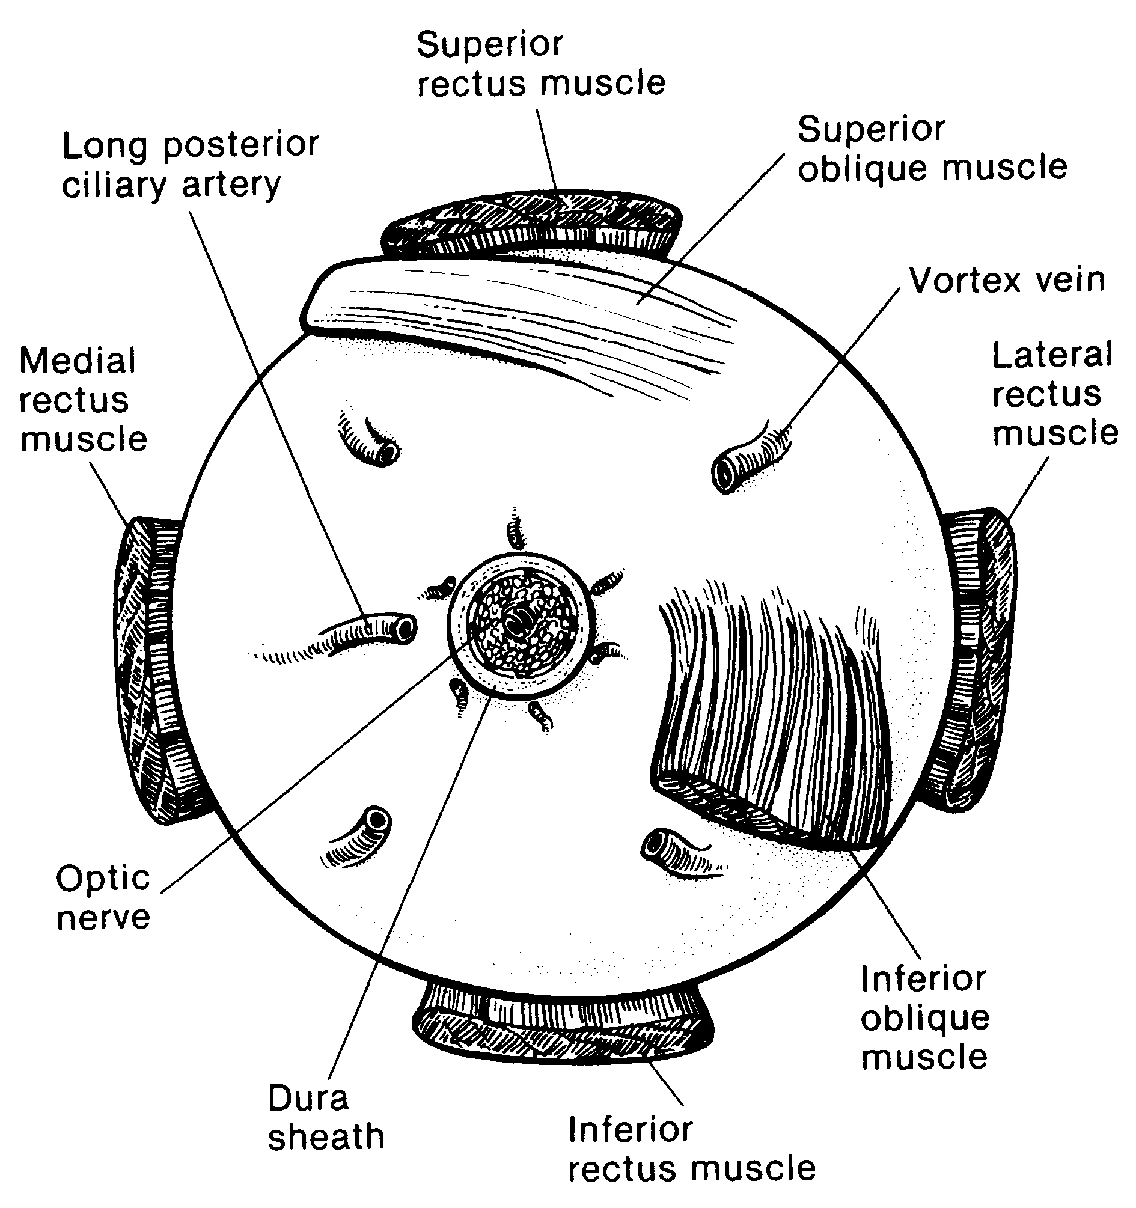
Figure 1. Anatomic landmarks of the posterior aspect of the globe (right eye). The position of the inferior oblique muscle relative to the optic nerve is most helpful in orienting the globe. The inferior oblique muscle insertion is located temporal (lateral) to the optic nerve on the sclera, and its fibers travel inferonasally from its insertion. The long posterior ciliary artery is often seen as a blue-gray line in the sclera on either side of the optic nerve and marks the horizontal meridian of the globe. Reprinted with permission from WB Saunders Company.

F. Processing Without Tumor Sampling
If there is no need for fresh tissue sampling, the enucleated globe should simply be fixed in 10% buffered formaldehyde for at least 24 and preferably 48 hours. When the fixed globe is examined by the pathologist, if the optic nerve was not previously amputated in the operative room, that should be performed first as described above. The surgical margin of the nerve stump should be embedded face down in paraffin for sectioning (ie, thereby obtaining cross-sections of the nerve, starting at the surgical margin). Then, the eye itself is sectioned. First, a section should be made that extends from pupil through the optic nerve (the “P-O” section), which contains the center of the optic nerve with all the optic nerve structures (optic nerve head, lamina cribrosa, and postlaminar optic nerve). Preferably this plane should bisect the largest dimension of the tumor, previously identified by transillumination and during clinical examination. When possible, the plane should avoid the scleral opening if one was made for fresh tumor sampling. This section is critical for evaluation of the optic nerve for tumor invasion. The P-O section and minor calottes are then embedded in paraffin. The embedded P-O calotte is then sectioned every 100 to 150 microns (each section being about 5 microns thick), for a total of about 10 to 20 sections. Additional sections should also be made anterior-posteriorly in a bread-loaf fashion through the minor callotes. These segments should be submitted in 1 cassette per calotte on edge to evaluate the choroid for invasion. Three levels of this block are usually sufficient for examination. In total, 4 cassettes are submitted: the optic nerve stump, the P-O section, and the 2 minor calottes (unless 1 or both of these has no visible tumor).

G. Sectioning the Globe
The globe is generally sectioned in the horizontal or vertical plane, with care to include the pupil and optic nerve in the cassette to be submitted for microscopic examination. If the mass cannot be included with horizontal or vertical sectioning, the globe is sectioned obliquely to include tumor, pupil, and optic nerve (Figure 2). The surgical margin of the optic nerve should be sectioned and submitted prior to sectioning the globe to ensure that intraocular malignant cells do not contaminate this important surgical margin.³ Retinoblastoma is an extremely friable tumor.

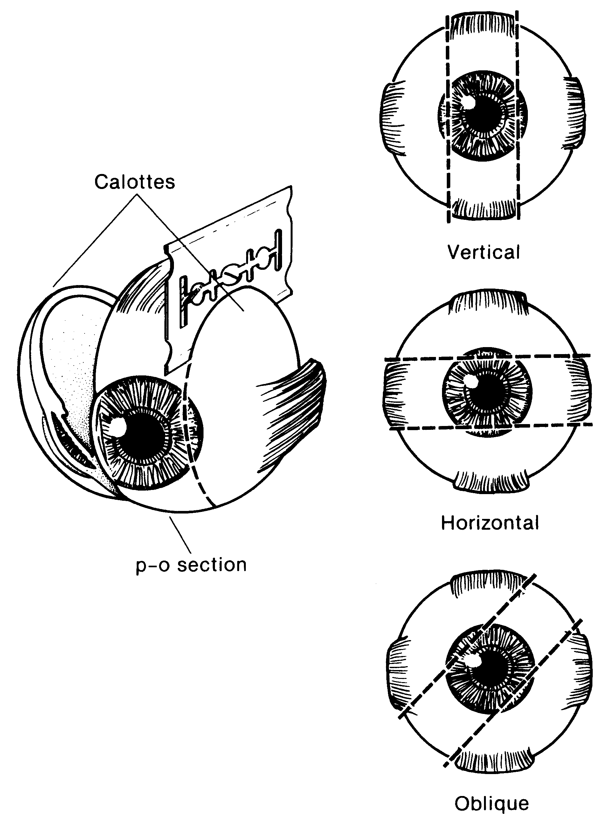
Figure 2. The most common methods of sectioning a globe. After transillumination, the tumor base is marked, if possible, and included in the pupil-optic (p-o) nerve section and submitted for processing. If tumor is found in either of the calottes, these may also be submitted for sectioning. The meridian in which the globe was sectioned should be included in the gross description of the pathology report. It is not uncommon to induce an artifactitious retinal detachment while sectioning the globe. This can be minimized by gentle handling and by avoiding a sawing motion with the blade. Reprinted with permission from WB Saunders Company.

Each calotte should also be sampled. The calottes should be breadloafed and submitted in a cassette on edge for processing as shown in Figure 3.

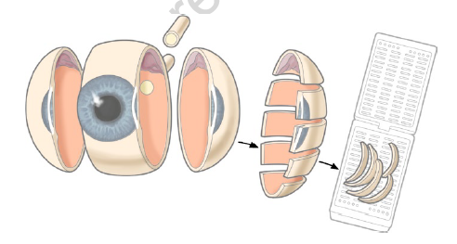
Figure 3. Calotte sampling. From Grossniklaus HE.¹⁸ Reproduced with kind permission of Springer Science+Business Media.

H. Sections Submitted for Microscopic Examination
Multiple sections should be examined, with special attention to sections containing optic nerve and tumor. The nerve should be sectioned along the various levels to determine tumor extension.

I. Rules for Classification

Choroidal invasion: The presence and the extent (focal versus massive) of choroidal invasion by tumor should be stated. Differentiation should be made between true choroidal invasion and artifactual invasion due to seeding of fresh tumor cells during post-enucleation retrieval of tumor tissue and/or gross sectioning.

Artifactual invasion is identified when there are groups of tumor cells present in the open spaces between intraocular structures, extraocular tissues and/or subarachnoid space.

True invasion is defined as 1 or more solid nests of tumor cells that fills or replaces the choroid and has pushing borders. Note: Invasion of the sub-retinal pigment epithelium (RPE) space, where tumor cells are present under the RPE (but not beyond Bruch’s membrane into the choroid) is not choroidal invasion.

Focal choroidal invasion is defined as a solid nest of tumor that measures less than 3 mm in maximum diameter (width or thickness).

Massive choroidal invasion is defined as a solid tumor nest 3 mm or more in maximum diameter (width or thickness) in contact with the underlying sclera.

J. Growth Pattern
Endophytic growth pattern indicates growth from the inner retinal surface into the vitreous cavity. Exophytic tumors grow primarily from the outer surface of the retina into the subretinal space toward the choroid. Mixed growth pattern exhibits features of both endophytic and exophytic growth. Diffuse infiltrating tumors grow laterally within the retina without significant thickening.

K. Histologic Features
Histopathologic features of retinoblastoma include small round cells staining blue on hematoxylin-eosin. Flexner-Wintersteiner rosettes (typical for retinoblastoma) and Homer-Wright rosettes (characteristic of neuroectodermal tumors) both occur. Tumors with many Flexner-Wintersteiner rosettes are graded as moderately differentiated. Some tumors show photoreceptor-like differentiation (fleurettes) or neuronal differentiation without mitoses or apoptosis, which is evidence of an underlying premalignant lesion: retinocytoma.^{4,5} It is not uncommon to find a retinocytomatous area at the base of the tumor.⁶ Retinocytomatous areas are more resistant to chemotherapy and, occasionally, only the retinocytomatous part may remain viable, surrounded by calcifications and debris from the regressed retinoblastoma that it spawned. Tumors that show no fleurettes or rosettes are graded as poorly differentiated. The nuclei of poorly differentiated tumors may show anaplasia.⁷ Rarely, unilateral retinoblastoma tumors show a loose cellular pattern with round nuclei and prominent multiple nucleoli indicative of MYCN amplification and normal RB1 alleles.⁸ Retinoblastoma undergoes pathognomonic dystrophic calcification. Small tumors initially are limited by the retinal boundaries (Bruch’s membrane and the inner limiting membrane). As the tumor grows, it spreads into the adjacent vitreous, subretinal space, underlying choroid, optic nerve, or anterior segment (iris, trabecular meshwork, or Schlemm’s canal).

L. Histologic Features of Additional Prognostic Significance
Histologic features with prognostic significance for survival include the following: invasion of optic nerve, particularly if tumor is present at the surgical margin (most important feature); invasion of sclera; invasion of choroid; tumor size; basophilic staining of tumor vessels; seeding of vitreous; degree of differentiation; involvement of anterior segment; and growth pattern.⁹⁻¹⁵ This list should not be confused with the Reese-Ellsworth classification, which is intended as a predictor for visual outcome, not survival.¹⁶

M. Pathologic Stage Classification
The American Joint Committee on Cancer (AJCC) and the International Union Against Cancer (UICC) TNM staging system for retinoblastoma is shown below.¹⁸

By AJCC/UICC convention, the designation “T” refers to a primary tumor that has not been previously treated. The symbol “p” refers to the pathologic classification of the TNM, as opposed to the clinical classification, and is based on gross and microscopic examination. pT entails a resection of the primary tumor or biopsy adequate to evaluate the highest pT category, pN entails removal of nodes adequate to validate lymph node metastasis, and pM implies microscopic examination of distant lesions. It is not uncommon to receive an eye of histopathologic examination that has been enucleated after failed conservative treatment such as chemoreduction or intra-arterial chemosurgery combined with focal treatments and radiotherapy. In such cases, the symbol “y” referring to a treated tumor and/or the symbol “r” referring to a recurrent tumor may be added. Clinical classification (cTNM) is usually carried out by the referring physician before treatment during initial evaluation of the patient or when pathologic classification is not possible.

Pathologic staging is usually performed after surgical resection of the primary tumor. Pathologic staging depends on pathologic documentation of the anatomic extent of disease, whether or not the primary tumor has been completely removed. If a biopsied tumor is not resected for any reason (eg, when technically unfeasible) and if the highest T and N categories or the M1 category of the tumor can be confirmed microscopically, the criteria for pathologic classification and staging have been satisfied without total removal of the primary cancer.

TNM Descriptors
For identification of special cases of TNM or pTNM classifications, the “m” suffix and “y,” “r,” and “a” prefixes are used. Although they do not affect the stage grouping, they indicate cases needing separate analysis.

The “m” suffix indicates the presence of multiple primary tumors in a single site and is recorded in parentheses: pT(m)NM.

The “y” prefix indicates those cases in which classification is performed during or following initial multimodality therapy (ie, neoadjuvant chemotherapy, radiation therapy, or both chemotherapy and radiation therapy). The cTNM or pTNM category is identified by a “y” prefix. The ycTNM or ypTNM categorizes the extent of tumor actually present at the time of that examination. The “y” categorization is not an estimate of tumor prior to multimodality therapy (ie, before initiation of neoadjuvant therapy).

The “r” prefix indicates a recurrent tumor when staged after a documented disease-free interval, and is identified by the “r” prefix: rTNM.

The “a” prefix designates the stage determined at autopsy: aTNM.

Additional Descriptors

Residual Tumor (R)
Tumor remaining in a patient after therapy with curative intent (eg, surgical resection for cure) is categorized by a system known as R classification, shown below.

RX Presence of residual tumor cannot be assessed
R0 No residual tumor
R1 Microscopic residual tumor
R2 Macroscopic residual tumor

For the surgeon, the R classification may be useful to indicate the known or assumed status of the completeness of a surgical excision. For the pathologist, the R classification is relevant to the status of the margins of a surgical resection specimen. That is, tumor involving the resection margin on pathologic examination may be assumed to correspond to residual tumor in the patient and may be classified as macroscopic or microscopic according to the findings at the specimen margin(s).
T Category Considerations

Lymph-Vascular Invasion (LVI)
LVI indicates whether microscopic lymph-vascular invasion is identified in the pathology report. LVI includes lymphatic invasion, vascular invasion, or lymph-vascular invasion. By AJCC/UICC convention, LVI does not affect the T category indicating local extent of tumor unless specifically included in the definition of a T category.

Clinical TNM Classifications:
Primary Tumor (T)
TX Primary tumor cannot be assessed.
T0 No evidence of primary tumor.
cT1 Intraretinal tumor(s) with subretinal fluid ≤5 mm from the base of any tumor
cT1a Tumors ≤3 mm and further than 1.5 mm from disc and fovea
cT1b Tumors >3 mm or closer than 1.5 mm from disc or fovea
cT2 Intraocular tumor(s) with retinal detachment, vitreous seeding, or subretinal seeding
cT2a Subretinal fluid >5 mm from the base of any tumor
cT2b Vitreous seeding and/or subretinal seeding
cT3 Advanced intraocular tumor(s)
cT3a Phthisis or pre-phthisis bulbi
cT3b Tumor invasion of choroid, pars plana, ciliary body, lens, zonules, iris, or anterior chamber
cT3c Raised intraocular pressure with neovascularization and/or buphthalmos
cT3d Hyphema and/or massive vitreous hemorrhage
cT3e Aseptic orbital cellulitis
cT4 Extraocular tumor(s) involving orbit, including optic nerve
cT4a Radiologic evidence of retrobulbar optic nerve involvement or thickening of optic nerve or involvement of orbital tissues
cT4b Extraocular tumor clinically evident with proptosis and/or an orbital mass

Regional Lymph Nodes (N)
cNX Regional lymph nodes cannot be assessed
cN0 No regional lymph node involvement
cN1 Regional lymph node involvement (preauricular, cervical, submandibular)

Metastasis (M)
cM0 No metastasis
cM1 Distant metastasis without microscopic confirmation
cM1a Tumor(s) involving any distant site (e.g., bone marrow, liver) on clinical or radiologic tests
cM1b Tumor involving the CNS on radiologic imaging (not including trilateral retinoblastoma)

Definition of Heritable Trait (H)
HX Unknown or insufficient evidence of a constitutional RB1 gene mutation.
H0 Normal RB1 alleles in blood tested with demonstrated high-sensitivity assays
H1 Bilateral retinoblastoma, any retinoblastoma with an intracranial primitive neuroectodermal tumor (ie, trilateral retinoblastoma), patient with family history of retinoblastoma, or molecular definition of a constitutional RB1 gene mutation

TNM Prognostic Stage Groupings

Clinical Stage (cTNM)

When cT is.. | And N is… | And M is… | And H is… | Then the clinical stage group is…
cT1, cT2, cT3 | cN0 | cM0 | Any | I
cT4a | cN0 | cM0 | Any | II
cT4b | cN0 | cM0 | Any | III
Any | cN1 | cM0 | Any | III
Any | Any | cM1 or pM1 | Any | IV

Pathologic Stage (pTNM)

When pT is.. | And N is… | And M is… | And H is… | Then the pathologic stage group is…
pT1, pT2, pT3 | pN0 | cM0 | Any | I
pT4 | pN0 | cM0 | Any | II
Any | pN1 | cM0 | Any | III
Any | Any | cM1 or pM1 | Any | IV

WHO Classification of Tumors
International Agency for Research on Cancer, World Health Organization. International Classification of Diseases for Oncology. ICD-O-3-Online. http://codes.iarc.fr/home. Accessed May 15, 2016.

Code | Description
9510 | Retinoblastoma, NOS
9511 | Retinoblastoma, differentiated
9512 | Retinoblastoma, undifferentiated
9513 | Retinoblastoma, diffuse

References
1. Karcioglu ZA, Gordon RA, Karcioglu GL. Tumor seeding in ocular fine needle aspiration biopsy. Ophthalmology. 1985;92:1763-1767.
2. Stevenson KE, Hungerford J, Garner A. Local extraocular extension of retinoblastoma following intraocular surgery. Br J Ophthalmol. 1989;73:739-742.
3. Shields JA, Shields CL, De Potter P. Enucleation technique for children with retinoblastoma. J Ped Ophthalmol Strabismus. 1992;29:213-215.
4. Gallie BL, Ellsworth RM, Abramson DH, Phillips RA. Retinoma: spontaneous regression of retinoblastoma or benign manifestation of the mutation? Br J Cancer. 1982;45(4):513-521.
5. Dimaras H, Khetan V, Halliday W, et al. Loss of RB1 induces non-proliferative retinoma: increasing genomic instability correlates with progression to retinoblastoma. Hum Mol Genet. 2008;17(10):1363-1372.
6. Eagle RC Jr. High-risk features and tumor differentiation in retinoblastoma: a retrospective histopathologic study. Arch Pathol Lab Med. 2009;133(8):1203-1209.
7. Mendoza PR, Specht CS, Hubbard GB, et al. Histopathologic grading of anaplasia in retinoblastoma. Am J Ophthalmol. 2015;159(4):764-776.
8. Rushlow DE, Mol BM, Kennett JY, et al. Characterisation of retinoblastomas without RB1 mutations: genomic, gene expression, and clinical studies. Lancet Oncol. 2013;14(4):327-334.
9 Redler LD, Ellsworth RM. Prognostic importance of choroidal invasion in retinoblastoma. Arch Ophthalmol. 1973;90:294-296.
10. Kopelman JE, McLean IW. Multivariate analysis of clinical and histological risk factors for metastasis in retinoblastoma [abstract]. Invest Ophthalmol Vis Sci. 1983;24(ARVO suppl):50.
11. Kopelman JE, McLean IW. Multivariate analysis of risk factors for metastasis in retinoblastoma treated by enucleation. Ophthalmology. 1987;94:371-377.
12. Haik BG, Dunleavy SA, Cooke C, et al. Retinoblastoma with anterior chamber extension. Ophthalmology. 1987;94:367-370.
13. Magramm I, Abramson DH, Ellsworth RM. Optic nerve involvement in retinoblastoma. Ophthalmology. 1989;96:217-222.
14. Shields CL, Shields JA, Baez KA, Cater J, De Potter PV. Choroidal invasion of retinoblastoma: metastatic potential and clinical risk factors. Br J Ophthalmol. 1993;77:544-548.
15. Shields CL, Shields JA, Baez K, Cater JR, De Potter P. Optic nerve invasion of retinoblastoma: metastatic potential and clinical risk factors. Cancer. 1994;73:692-698.
16. Reese AB, Ellsworth RM. The evaluation and current concept of retinoblastoma therapy. Trans Am Acad Ophthalmol Otolaryngol. 1963;67:164-172.
17. Amin MB, Edge SB, Greene FL, et al, eds. AJCC Cancer Staging Manual. 8th ed. New York, NY: Springer; 2017.
18. Brown HH, Wells JR, Grossniklaus HE. Chapter 11. Tissue preparation for pathologic examination. In: Grossniklaus HE, ed. Pocket Guide to Ocular Oncology and Pathology. Heidelberg, Germany: Springer; 2013.

